Final Report

Bryson Potts, Joseph Earnest, Manning Owens, Steven Harrington, Tamara Mccaskill

Florida State University, Panama City

EML 4551C – Senior Design 1

Dr. Damion Dunlap



# **Table of Contents**

**Table of Contents** **2**

**Disclaimer** **5**

**Abstract** **6**

**Work Breakdown Structure** **7**

**Mission Statement** **11**

**Team Roles** **12**

**Communication Policy** **14**

**Dress Code Policy** **15**

**Attendance Policy** **16**

**Code of Conduct** **16**

**Project Description** **16**

**Key Goals** **17**

**Market** **18**

**Stakeholders** **19**

**Assumptions** **20**

**Statement of Understanding** **21**

**Targets and Metrics - Introduction** **35**

**Derivation of Targets and Metrics** **36**

**Explanation of Targets and Metrics** **37**

**Critical Targets and Metrics** **40**

**Methods of Validation** **41**

**Discussion of Measurements** **44**

**Targets and Metrics Summary** **45**

**Concept Generation Introduction** **48**

**Concept Generation Tools** **48**

**Medium Fidelity Concepts** **49**

**100 Concepts** **57**

**Concept Generation Conclusion** **61**

**Concept Selection Introduction** **62**

**Binary Comparison Chart** **63**

**House of Quality (HoQ)** **64**

**AHP** **66**

**Pugh Chart** **68**

**Decision Matrix** **70**

**Final Decision** **71**

**Bill of Materials** **73**

**Prototype Plan** **74**

**Hull Prototypes** **74**

**Software Prototype** **74**

**Assessment Plan** **75**

**Risk Assessment** **76**

**Manufacturing** **76**

**Wiring** **76**

**Testing and Transportation** **76**

**Risk Mitigation** **77**

**Restated Project Charter** **83**

**Mission Statement** **83**

**Team Roles** **83**

**Communication Policy** **85**

**Dress Code Policy** **85**

Attendance Policy 86

Code of Conduct 87

Project Description 87

Key Goals 87

Market 88

Stakeholders 88

Assumptions 89

Statement of Understanding 89

**Critical Design Review** **91**

Introduction 91

Revised Requirements 92

Submissions 93

Current Design Review 94

**Test Readiness Review** **97**

Project Overview 97

Project Background 97

Boat Specifications and Status Update 98

Assessment Plan 99

Safety Plan 100

Testing Results 100

Final Standings 100

**High Resolution Graphic** **101**

**Team Photo** **102**

**Appendix** **103**

**Appendix B - Concept Combinations** **128**

Concept 1 128

**Appendix C - 100 Possible Concepts** **132**

**Appendix D - Bill of Materials** **136**

**Appendix E - Risk Management** **137**

**Operation Manual** **143**

# 

# **Disclaimer**

Sections of this report were valid at the time of initial documentation; however, design specifications no longer entirely coincide due to unforeseeable events that have occurred since then.

# **Abstract**

The FSU PC 524 Senior Design Team's goal was to build a boat for the 2021 RoboBoat competition. When the semester began, our Mechanical Engineering team set out to construct the boat, as well as the electronics and coding needed to compete in the physical competition. A few weeks later, we merged with the Electrical Engineering RoboBoat Senior Design team, and our goals were changed to be complimentary. The mechanical side of the project would concentrate on the construction of a boat hull, an electronics access lid, and any structural subsystems that would be necessary. The subsystems included a tilt mechanism to alter the angle at which the LiDAR rested on the boat (for enhanced sightlines to items around the boat) and propulsor hot swaps, which allowed for quick thruster changes if one broke or malfunctioned. Shortly after combining with the Electrical Engineering team, we learned that the competition had been switched to an online submission, eliminating the requirement for a physical boat. A video demonstration of the hull and a technical report on the design process, was requested. At that time, we had only produced prototypes of the hull at a ⅙ volume scale model but decided to move on with a full-scale model after floatation testing. We intended to have the boat professionally manufactured at HPMI FSU (High Performance Materials Institute), however our plans fell through within the first few weeks of the summer semester (setback one). Then we made arrangements to utilize Gulf Coast State College's resources, but that, too, did not work out (setback 2). The hull and lid were created using a manual lay-up of fiberglass as an alternate method. This procedure produced a few flaws and altered several features of the boat's design. In the end, we were still able to accomplish our goal of building a boat that sits level in the water for the electrical team to integrate components into.

# **Work Breakdown Structure**

|  |  |  |  |  |  |  |
| --- | --- | --- | --- | --- | --- | --- |
| **SENIOR DESIGN: ROBOBOAT** | | | | | | |
| **LEVEL** | | | **TASK** | **PERCENTAGE** | **STATUS** | **PERSON(S)** |
| **1.0** |  |  | **ROBOBOAT PROJECT** | 100% | Complete | Team |
|  | **1.1** |  | **Milestone 1: WBS** | 100% | Complete | Team |
|  |  | **1.1.1** | *-Break down the project milestones into the work that must be done to complete these items.* | 100% | Complete | Bryson Potts |
|  | **1.2** |  | **Milestone 2: PROJECT CHARTER** | 100% | Complete |  |
|  |  | **1.2.1** | *-Create a Mission Statement* | 100% | Complete | Bryson Potts |
|  |  | **1.2.2** | *-Create a Project Description* | 100% | Complete | Joseph Earnest |
|  |  | **1.2.3** | *-Identify market* | 100% | Complete | Manning Owens |
|  |  | **1.2.4** | *-Identify Stakeholders* | 100% | Complete | Steven Harrington |
|  |  | **1.2.5** | *-Develop Assumptions* | 100% | Complete | Tamara Mccaskill |
|  |  | **1.2.6** | *-Define Key Goals* | 100% | Complete | Bryson Potts |
|  |  | **1.2.7** | *-Assign Team Roles and Responsibilities* | 100% | Complete | Joseph Earnest |
|  |  | **1.2.8** | *-Create a Communication Policy* | 100% | Complete | Manning Owens |
|  |  | **1.2.9** | *-Develop a Dress Code Policy* | 100% | Complete | Steven Harrington |
|  |  | **1.2.10** | *-Develop an Attendance Policy* | 100% | Complete | Tamara Mccaskill |
|  |  | **1.2.11** | *-Create Statement of Understanding* | 100% | Complete | Bryson Potts |
|  |  | **1.2.12** | *-Develop Code of Conduct Policy* | 100% | Complete | Joseph Earnest |
|  |  | **1.2.13** | *-Submit a hard copy on canvas* | 100% | Complete | Manning Owens |
|  | **1.3** |  | **Milestone 3: CUSTOMER NEEDS** | 100% | Complete |  |
|  |  | **1.3.1** | *-Develop a Customer Needs Statement* | 100% | Complete | Steven Harrington |
|  |  | **1.3.2** | *-Create questions to ask customer* | 100% | Complete | Tamara Mccaskill |
|  |  | **1.3.3** | -Create customer responses | 100% | Complete | Bryson Potts |
|  |  | **1.3.4** | *-Describe how customer needs are being turned into a specification* | 100% | Complete | Joseph Earnest |
|  | **1.4** |  | **Milestone 4: FUNCTIONAL DECOMPOSITION** | 100% | Complete |  |
|  |  | **1.4.1** | *-Create a functional decomposition chart for boat (using software)* | 100% | Complete | Manning Owens |
|  |  | **1.4.2** | *-Identify major functions* | 100% | Complete | Steven Harrington |
|  |  | **1.4.3** | *-Identify sub-functions* | 100% | Complete | Tamara Mccaskill |
|  |  | **1.4.4** | *-Explain how sublevels correlate to the high level function of each column* | 100% | Complete | Bryson Potts |
|  |  | **1.4.5** | *-Identify physical action and expected outcome* | 100% | Complete | Joseph Earnest |
|  | **1.5** |  | **Milestone 5: PHASE 1 DESIGN REVIEW** | 100% | Complete |  |
|  |  | **1.5.1** | *- Develop and submit presentation* | 100% | Complete | Manning Owens |
|  |  | **1.5.2** | *- Introduction* | 100% | Complete | Steven Harrington |
|  |  | **1.5.3** | *- Project Brief Summary* | 100% | Complete | Tamara Mccaskill |
|  |  | **1.5.4** | *- Background* | 100% | Complete | Bryson Potts |
|  |  | **1.5.5** | *- Design Status* | 100% | Complete | Joseph Earnest |
|  |  | **1.5.6** | *- Project Plan (schedule and budget)* | 100% | Complete | Manning Owens |
|  |  | **1.5.7** | *- Score team being observed* | 100% | Complete | Steven Harrington |
|  | **1.6** |  | **Milestone 6 : TARGETS** | 100% | Complete |  |
|  |  | **1.6.1** | *- Generate and log the targets* | 100% | Complete | Tamara Mccaskill |
|  |  | **1.6.2** | *- Write summary of the targets* | 100% | Complete | Bryson Potts |
|  |  | **1.6.3** | *- Write summary of how targets were established* | 100% | Complete | Joseph Earnest |
|  |  | **1.6.4** | *- Write about the targets that interest the customer (customer needs)* | 100% | Complete | Manning Owens |
|  | **1.7** |  | **Milestone 7: CONCEPT GENERATION** | 100% | Complete |  |
|  |  | **1.7.1** | *- Generate and submit concepts* | 100% | Complete | Steven Harrington |
|  |  | **1.7.2** | *- 5 Medium Fidelity Concepts* | 100% | Complete | Tamara Mccaskill |
|  |  | **1.7.3** | *- 3 High Fidelity Concepts* | 100% | Complete | Bryson Potts |
|  |  | **1.7.4** | *- 100+ Concepts made* | 100% | Complete | Joseph Earnest |
|  | **1.8** |  | **Milestone 8 : CONCEPT SELECTION** | 100% | Complete |  |
|  |  | **1.8.1** | *- Using an engineering decision making document, designate a winning concept* | 100% | Complete | Manning Owens |
|  |  | **1.8.2** | *- House of Quality* | 100% | Complete | Steven Harrington |
|  |  | **1.8.3** | *- Pugh Charts* | 100% | Complete | Tamara Mccaskill |
|  |  | **1.8.4** | *- AHP* | 100% | Complete | Bryson Potts |
|  |  | **1.8.5** | *- Final Selection* | 100% | Complete | Joseph Earnest |
|  | **1.9** |  | **Milestone 9: PHASE 2 DESIGN REVIEW** | 100% | Complete |  |
|  |  | **1.9.1** | *- Develop and submit presentation* | 100% | Complete | Manning Owens |
|  |  | **1.9.2** | *- Targets* | 100% | Complete | Steven Harrington |
|  |  | **1.9.3** | *- Concept Generation* | 100% | Complete | Tamara Mccaskill |
|  |  | **1.9.4** | *- Concept Selection* | 100% | Complete | Bryson Potts |
|  |  | **1.9.5** | *- Design Status* | 100% | Complete | Joseph Earnest |
|  |  | **1.9.6** | *- Future Plans* | 100% | Complete | Manning Owens |
|  |  | **1.9.7** | *- Score team being observed* | 100% | Complete | Steven Harrington |
|  | **1.10** |  | **Milestone 10: BILL OF MATERIALS** | 100% | Complete |  |
|  |  | **1.10.1** | *- Develop and submit the Bill of Materials* | 100% | Complete | Tamara Mccaskill |
|  |  | **1.10.2** | *- Bill of Materials* | 100% | Complete | Bryson Potts |
|  | **1.11** |  | **Milestone 11: PROTOTYPE PLAN** | 100% | Complete |  |
|  |  | **1.11.1** | **- No current information available** | 100% | Complete | Joseph Earnest |
|  | **1.12** |  | **Milestone 12: RISK ASSESSMENT** | 100% | Complete |  |
|  |  | **1.12.1** | *- Complete and submit the safety forms* | 100% | Complete | Joseph Earnest |
|  |  | **1.12.2** | *- Safety Expectations* | 100% | Complete | Manning Owens |
|  |  | **1.12.3** | *- Worksheet 1 (project hazard assessment)* | 100% | Complete | Steven Harrington |
|  |  | **1.12.4** | *- Worksheet 2 (project control)* | 100% | Complete | Tamara Mccaskill |
|  | **1.13** |  | **Milestone 13: SUMMER PROJECT PLAN (WBS UPDATE)** | 100% | Complete |  |
|  |  | **1.13.1** | *- Develop and submit plan for summer* | 100% | Complete | Bryson Potts |
|  |  | **1.13.2** | *- Document timeline, milestones, and deliverables* | 100% | Complete | Joseph Earnest |
|  | **1.14** |  | **Milestone 14 : PHASE 3 DESIGN REVIEW (POSTER)** | 100% | Complete |  |
|  |  | **1.14.1** | *- PDF of poster (24x36 in) summary of all work to this point and future work* | 100% | Complete | Manning Owens |
|  | **1.15** |  | **Milestone 15 : FINAL REPORT (SPRING)** | 100% | Complete |  |

**Table 1**

# **Mission Statement**

Our mission is to demonstrate skills acquired through FSU-PC’s mechanical engineering program by constructing a boat that is capable of meeting the RoboBoat competition standards.

# **Team Roles**

**Team Lead - Bryson Potts**

The team lead focuses on the overall production of the project and is knowledgeable in all areas of the project’s requirements.

* Main point of contact with advisor/sponsors
* Oversees the entire project to make sure that all areas are covered
* Ensures that everyone understands what they are doing

**Secretary - Tamara McCaskill**

The secretary maintains group organization.

* Records meeting minutes
* Reorganizes throughout the project as necessary

**Builders - Manning Owens, Steven Harrington, and Tamara McCaskill**

The builders focus on the physical design, fabrication and assembly of the project. These components include:

* Material Selection
* Hull Design
* Construction and Fabrication
* Propulsion Design
* Weight Distribution

**Subsystem Designs - Bryson Potts, Joseph Earnest**

The Subsystem Designer will build prototypes in modeling software and physically to test the reliability and functionality of the design to ensure final product reliability.

* Test and build subsystem prototypes
* Improve said prototypes

Additional project related tasks will be assigned based on team member availability.

# 

# 

# 

# **Communication Policy**

University emails, official communications, and outside resources, including but not limited to: Google Documents, Zoom, WhatsApp and Basecamp, will be used as methods of communication. Scheduling meetings and assigning work will occur through WhatsApp, any conflicts to completing assignments or attending meetings should be stated at least 24 hours in advance via WhatsApp. File sharing will occur through either Basecamp, Google Documents, or via preferred email address. It is the sole responsibility of each member to receive such communications and to respond as needed within 24 hours.

# **Dress Code Policy**

**Policy Statement:**

All Clothing must be in good taste and conducive to the function. Roboboat members will wear business attire for presentations/sponsor interactions and casual attire for team meetings.

**Business/Professional Attire:**

Members should choose business attire such as dresses, pants, shirts, blouses, dress shirts, ties, suits, and skirts. Open toe shoes and sandals are not allowed

**Casual Attire:**

Members should choose casual attires such as jeans, shorts and any other relaxed clothing for everyday wear. Open toe shoes and sandals are allowed.

# **Attendance Policy**

**Attendance policy overview.**

Participants in the RoboBoat group are expected to be present and on time for all scheduled project meetings and work. Being tardy or absent should be minimized as it causes disruptions and burdens colleagues.

# **Code of Conduct**

The RoboBoat team will

1. Carry out their responsibilities in a timely manner, with notice of delays.
2. Practice honesty and integrity to the trust placed in completing work.
3. Be respectful to other members.
4. Openly share information and cooperate with peers in discussions and meetings
5. Be present for all meetings with prior notice of delays or absences.
6. Abide by the principles established in this code

# **Project Description**

The goal of this project is to design and build a boat with autonomous function that is capable of completing the course objectives for the 2021 RoboBoat Competition.

# **Key Goals**

The key goals of this design project are:

* Construct an easily maneuverable, stable boat
* Fully autonomous navigation of surroundings with a remote-controllable mode
* Be able to determine surrounding obstacles/environment
* Implement a visual feedback system capable of relaying the POV of the boat.

# **Market**

The market for this project includes the companies that attend the competition scouting for potential employees based on the technical skills demonstrated, and companies that focus on autonomous maritime development. Some of these companies include:

* Office of Naval Research
* SolidWorks
* NVIDIA
* Velodyne Lidar
* Siemens
* Mathworks

# **Stakeholders**

Stakeholders are the Individuals and Organizations who want the project to be successful. Some of these include:

* Project Advisor
* Dr. Damion Dunlap
* Florida State University Administration
* Florida State STEM Department
* SPEAR club
* Independent RoboBoat Club Donors
* RoboBoat Senior Design Team

# 

# 

# **Assumptions**

* Any monetary need is funded
* Any need for tools and manufacturing is available
* Covid-19 will not hinder the ability to work on the RoboBoat
* Competition will be held despite Covid-19
* Weather will not cause the competition to be cancelled
* Weather will not conflict with the ability to test the RoboBoat
* Will be competing in freshwater
* No big waves or wildlife disturbance
* Corrosion of the boat is negligible
* Able to perform testing and maintenance on the boat as often as desired
* Meets criteria to qualify for competition
* Input and help from the Electrical Engineering team
* Purchasing and manufacturing components are made/delivered on time

# **Statement of Understanding**

(i) I am aware that RoboBoat group’s policies are available to me in the POLICY folder on Basecamp. It is my responsibility to familiarize myself with these policies.

1. In addition, I confirm that I have received, read and understood the following policies:
   * + Mission Statement
     + Team Roles
     + Communication
     + Dress Code
     + Attendance Policy
2. I agree to conduct my activities in accordance with RoboBoat group’s policies and understand that breaching these standards may result in disciplinary action up to and including termination/removal from the group.

Signed: ______________________________ Date: _____________________

Signed: ______________________________ Date: _____________________

Signed: ______________________________ Date: _____________________

Signed: ______________________________ Date: _____________________

Signed: ______________________________ Date: _____________________

**Customer Needs**

Customer needs enable design teams to be more informed on the decisions and goals of the product/service in development. The customers for the RoboBoat senior design team are the sponsors/advisors that are providing the means for the team to compete. The customer needs were formulated using the 2020 RoboBoat competition guidelines and from additional expectations given by the team’s advisor, Dr. Damion Dunlap.

The customer needs consist of the following:

1. It cannot exceed 140 pounds, and would ideally be less than 70 pounds.
2. The vehicle cannot exceed six feet, by three feet, by three feet "box".
3. The competition takes place at a freshwater pond, but you will most likely be testing in saltwater conditions.
4. It is recommended the electrical components are covered.
5. Final demos are within the last two weeks of the summer semester, or if going to a competition plan to finish ideally a week before the competition.
6. It will be transported in a pickup truck with a covered cab.
7. Focus on the areas of the competition that will net the most points with the least amount of complexity.
8. The vehicle needs to be battery powered.
9. The vehicle must be fully autonomous, and all decisions can be made onboard the ASV.
10. Any propulsion system is fine (thruster, paddle, etc.), but moving parts must have a shroud.
11. All sharp, pointy, moving, or sensitive parts must be covered and marked.

**Interpreted Needs**

The interpreted need is the engineering interpretation of the customer need statements.

The interpreted needs consist of the following:

1. The overall weight of the ASV and UAV will be less than 140 pounds.
2. The boat will fit into a six feet, by three feet, by three feet "box".
3. The boat will function as intended in both freshwater and saltwater.
4. Electrical components will be covered in case of inopportune weather conditions.
5. The team will decide whether the boat is planned to go to the competition or not.
6. The boat will be able to fit and be secured in the bed of the truck.
7. Focus on the categories of the competition that accumulates the most points.
8. The watercraft will be provided power by a cordless energy source.
9. The boat will be capable of making decisions and functioning independently.
10. The propulsion system will be determined by team preference, with a covering in case of moving parts.
11. The boat will have appropriate safety measures befitting of the RoboBoat standards.

**Explanation of Results**

1. The data found in the RoboBoat competition guidelines contains the ideal total weight and maximum total weight for the ASV and UAV.
2. The data found in the RoboBoat competition guidelines contains the UAV size constraint.
3. The buoyancy of the boat may be different in freshwater vs saltwater. The competition will be conducted in freshwater (lower buoyancy), therefore we need to make the boat with fresh water as the primary water.
4. While it is not required that the electrical components be covered, it is highly recommended so that electrical components will not have water damage from rain.
5. If the team competes in the Roboboat competition, then the project has to be completed significantly sooner.
6. The boat can be damaged if it falls out of the truck while driving down the highway. To avoid this we will strap down the boat using ratchet straps.
7. Directing all focus to one aspect of the project can cause problems in other areas and ultimately compromise the design.
8. The best solution for a cordless energy source is a battery.
9. The boat will be controlled by a wireless controller.
10. The propulsion system that will be used needs to contain some drag to allow the boat to decelerate.
11. All necessary precautions will be taken, to assure that no problems will arise during the competition/showcase.

**Raw Customer Feedback**

**Question:** Would weight be an issue for this project?

**Answer:** It cannot exceed 140 pounds, and would ideally be less than 70 pounds.

**Interpreted Need:** The overall weight of the ASV and UAV will be less than 140 pounds.

**Explanation of Result:** The data found in the RoboBoat competition guidelines contains the ideal total weight and maximum total weight for the ASV and UAV.

**Question:** Would size be an issue for this project?

**Answer:** The vehicle cannot exceed six feet, by three feet, by three feet "box".

**Interpreted Need:** The boat will be smaller than the size constraint given.

**Explanation of Results:** The data found in the RoboBoat competition guidelines contains the UAV size constraint.

**Question:** What type of water will the boat be operating in?

**Answer:** The competition takes place at a freshwater pond, but you will most likely be testing in saltwater conditions.

**Interpreted Need:** The boat will need to function similarly in both freshwater and saltwater.

**Explanation of Results:** The buoyancy of the boat may be different in freshwater vs saltwater.

**Question:** Do the electrical components of the boat have to be enclosed?

**Answer:** It is recommended to have electrical components enclosed.

**Interpreted Need:** Electrical components will be covered in case of inopportune weather conditions.

**Explanation of Result:** While it is not required that the electrical components be covered, it is highly recommended so that electrical components will not have water damage from rain.

**Question:** When should the final product be completed?

**Answer:**  Final demos are within the last two weeks of the summer semester, or if going to a competition plan to finish ideally a week before the competition.

**Interpreted Need:** The team needs to decide whether the boat is planned to go to the competition.

**Explanation of Result:** If the team competes, then the project has to be completed significantly sooner.

**Question:** What will be the planned transportation for the boat to the competition?

**Answer:** It will be transported in a pickup truck with a covered cab.

**Interpreted Need:** The boat needs to be able to fit and be secured in the bed of the truck.

**Explanation of Result:** The boat can be damaged if it somehow fell out of the truck while driving down the highway.

**Question:** What aspect of the competition should we prioritize?

**Answer:** Focus on the areas of the competition that will net the most points with the least amount of complexity.

**Interpreted Need:** Focus on the categories of the competition that accumulates the most points.

**Explanation of Result:** Directing all focus to one aspect of the project can cause problems in other areas and ultimately compromise the design.

**Question:** Can the boat utilize any type of energy source?

**Answer:** The vehicle needs to be battery powered.

**Interpreted Need:** The watercraft will have power supplied by a cordless energy source.

**Explanation of Result:** The best solution for a cordless energy source is a battery.

**Question:** How much autonomy should our boat have?

**Answer:**  The vehicle must be fully autonomous, and all decisions must be taken onboard the ASV.

**Interpreted Need:** The boat will be capable of making decisions and functioning independently.

**Explanation of Result:** The boat will be controlled by a wireless controller.

**Question:** What propulsion systems are available for use?

**Answer:**  Any propulsion system is fine (thruster, paddle, etc.), but moving parts must have a shroud.

**Interpreted Need:** The propulsion system will be determined by team preference, with a covering in case of moving parts.

**Explanation of Result:** The propulsion system that will be used needs to contain some drag to allow the boat to stop quicker.

**Question:** What safety precautions should be taken?

**Answer:**  All sharp, pointy, moving, or sensitive parts must be covered and marked.

**Interpreted Need:** Boat will have appropriate safety measures befitting of the RoboBoat standards.

**Explanation of Result:** All necessary precautions will be taken to assure that no problems will arise during the competition/showcase.

|  |  |  |  |
| --- | --- | --- | --- |
| Question | Answer | Interpreted Need | Explanation of Results |
| Would weight be an issue for this project? | It cannot exceed 140 pounds, and would ideally be less than 70 pounds. | The overall weight of the ASV and UAV will be less than 140 pounds. | The data found in the RoboBoat competition guidelines contains the ideal total weight and maximum total weight for the ASV and UAV. |
| Would size be an issue for this project? | The vehicle cannot exceed six feet, by three feet, by three feet "box". | The boat will be smaller than the size constraint given | The data found in the RoboBoat competition guidelines contains the UAV size constraint. |
| What type of water will the boat be operating in? | The competition takes place at a freshwater pond, but you will most likely be testing in saltwater conditions. | The boat will be smaller than the size constraint given. | The buoyancy of the boat may be different in freshwater vs saltwater. |
| Do the electrical components of the boat have to be enclosed? | It is recommended the electrical components are covered. | Electrical components will be covered in case of inopportune weather conditions. | While it is not required that the electrical components be covered, it is highly recommended so that electrical components will not have water damage from rain. |
| When should the final product be completed? | Final demos are within the last two weeks of the summer semester, or if going to a competition plan to finish ideally a week before the competition. | The team needs to decide whether the boat is planned to go to the competition. | If the team competes, then the project has to be completed significantly sooner. |
| What will be the planned transportation for the boat to the competition? | It will be transported in a pickup truck with a covered cab. | The boat needs to be able to fit and be secured in the bed of the truck. | The boat can be damaged if it somehow fell out of the truck while driving down the highway. |
| What aspect of the competition should we prioritize? | Focus on the areas of the competition that will net the most points with the least amount of complexity | Try not to perfect one specific characteristic of the project. | Directing all focus to one aspect of the project can cause problems in other areas and ultimately compromise the design. |
| Can the boat utilize any type of energy source? | The vehicle needs to be battery powered. | The watercraft will have power supplied by a cordless energy source. | The best solution for a cordless energy source is a battery. |
| How much autonomy should our boat have? | The vehicle must be fully autonomous, and all decisions can be made onboard the ASV. | The boat will be capable of making decisions and functioning independently. | The boat will be controlled by a wireless controller. |
| What propulsion systems are available for use? | Any propulsion system is fine (thruster, paddle, etc.), but moving parts must have a shroud. | The propulsion system will be determined by team preference, with a covering in case of moving parts. | The propulsion system that will be used needs to contain some drag to allow the boat to stop quicker. |
| What safety precautions should be taken? | All sharp, pointy, moving, or sensitive parts must be covered and marked. | The boat will have appropriate safety measures befitting of the RoboBoat standards. | All necessary precautions will be taken to assure that no problems will arise during the competition/showcase. |

**Table 2**

**Functional Decomposition**

Functional decomposition is a process that involves breaking down a system's overall functions into smaller subparts. This is best achieved through team brainstorming sessions and the result is to make a diagram that illustrates how a design’s general tasks and subtasks fit together. The following functional decomposition breaks down the major and minor functions of an autonomous boat.

**Data Acquisition**

The data used to generate our functional decomposition came from the RoboBoat competition requirements and the customer needs. We prioritized the system’s functions around maneuverability, since a majority of the competition tasks utilize it. The interpreted needs were then simplified, so that the range of solutions were still broad. This technique prevented us from boxing ourselves into a single solution. Finally, we cross referenced the common simplified needs and turned them into our functions.

**Functional Decomposition Explanation**

As seen in Figure 1, the RoboBoat consists of 8 main functions; Support, Sense, Communicate, Process, Safeguard, Propulsion, Power, and Signal. The support function is for the stability and load carrying capabilities. The sense function is for the detection of surroundings and positions. The communicate function is for receiving and sending relevant information to the correct components. The process function is for interpreting the data received from the controller and data gathered by sensors. The safeguard function refers to the kill switch requirements (remote and manual) to be able to compete. The propulsion system is for the components used to move the boat, with turning and adjusting the speed of the boat. The power system refers to supplying energy to the boat components. The signal function is for the status of the operation of the boat (remote, autonomous, and if the emergency stop is active).

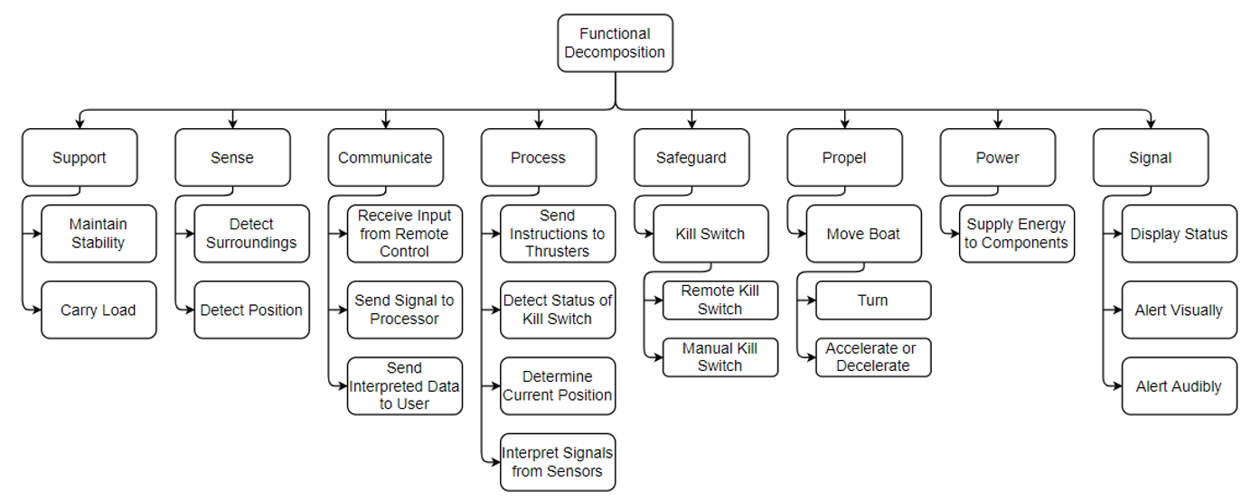

**Figure 1: Functional Decomposition**

**Function Relationships**

Support, Power and Propulsion are the main functions that will make the boat function, as without support there is no boat, without propulsion the boat is incapable of movement, and without power the propulsion/communication/process/signals can not function. Sense, Communicate and Process all directly relate as the sense function gives relevant environmental information to the processor, the communication function transfers remote and sensory data received from the sense function to the process function. The processor interprets the data received from the prior functions and determines the next action. The processor then tells the safeguard if it should activate, as well as how the propulsion system should activate, orient, or specify speed of the thrusters. It also updates the status of the signal function

**Actions and Outcomes**

The RoboBoat competition is a popular and growing autonomous boat competition. This boat will be able to propel and navigate a series of obstacles autonomously along with remote controller capabilities. The weight of the boat will allow for proper floatation, while the propulsion system provides stable directional motion. With the challenge of maneuvering and navigating, rotational motion and water friction will not cause the boat to capsize. The boat will also have to be able to store any electrical components and accessories that are required by the RoboBoat competition rules. The RoboBoat should be capable of completing the given tasks in an efficient and timely manner in order to compete for the best time.

**Function Resolution**

The purpose of this project is to construct and engineer an autonomous boat with the capabilities of remote control use. The autonomous boat will handle high-speed, stable maneuverability through a timed obstacle course, complete a speed run, handle obstacle delivery, and be capable of docking itself.

# **Targets and Metrics - Introduction**

Targets and metrics are vital in determining the end goal that a design needs to accomplish. The targets and metrics are mainly derived by the functions found in the functional decomposition. The mechanical engineering RoboBoat team is merging with the electrical engineering RoboBoat team, and they will have the final say on the power requirements.

A target is a specific value to design a product to meet. The metric is what method will be used to validate the function from the functional decomposition. There are a couple different types of measures; Performance, Physiological, Subjective, and Objective.

Performance measures are directly quantifiable and reproducible; such as a length, temperature, or pressure. This is easy to confirm, and some performance methods of the RoboBoat would include the weight, size.

Physiological measures are more difficult to measure, they include things that deal with the end user such as comfort, ease of use and mental workload. For the RoboBoat the physiological measures consisted of style.

Subjective measures are performance measurements measured by an end user (preferably a professional). The RoboBoat is not in the stage where subjective measurements can be determined.

Objective measurements are similar to performance but are typically measured with instrumentation. The RoboBoat objective measurements could include motor speed (rpm), thrust and GPS positional accuracy.

# 

# **Derivation of Targets and Metrics**

The functional decomposition was made by taking customer needs and forming them into distinct functions and subfunctions. The functional decomposition is then used to derive the targets and metrics for each function. The values for the targets and metrics were found via component specification sheets, goals based on previous competition performances, the electrical engineering senior design team, and advisor recommendations. The critical were determined as what was needed to have the bare minimum for a boat to compete.



**Figure 1: Functional Decomposition**

# 

# 

# **Explanation of Targets and Metrics**

The list below explains the functions and their relation to the targets and metrics

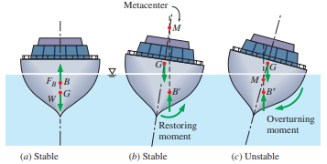

**Figure 2: Stability of Boats in regards to Center of Gravity vs Center of Buoyancy**

* **Maintain Stability:** A seen in Figure 2, to properly maintain stability the RoboBoat should have a center of gravity below the center of buoyancy, and as the boat rocks the metacentric height GM, which is the distance between the center of gravity G and the metacenter M, will self correct the boats stability. If the center of gravity is above the center of buoyancy then the boat's metacentric height will cause an overturning moment, capsizing the boat. Thus the team aims to have a boat that is bottom-heavy.
* **Carry Load:** The boat hull will contain/support the electrical workings, battery, sensors, processing unit, status indicators, and objects for delivery. The weight distribution and total weight will affect the center of gravity, and therefore directly affects maintaining stability. The target is to be under the weight limit (less than 140 lbs), with stable object placement.
* **Detect Surroundings:** The boat will be equipped with sensors capable of detecting the surroundings of the RoboBoat. Our goal is to detect objects up to 20 feet away.
* **Detect Position:** The boat will be equipped with some sort of GPS system capable of detecting the position of the RoboBoat. The position of the boat will be measured in GPS coordinates. The target is to have a GPS system that provides location within ____ range.
* **Communication:** The three sub functions under communication are “Receive Input from Remote Control”, “Send Signal to Processor”, and “Send Interpreted Data to User”. All of these will be measured in hertz, however each has a different target for the speed at which it needs to be communicated. “Receive Input from Remote Control” and “Send Signal to Processor” should both be at a high hertz rate because it is important that messages are sent to components of the RoboBoat fairly quickly. It is less important that the user see the interpreted data as quickly.
* **Process:** The targets and metrics for Process are similar to Communication. “Send Instructions to Thrusters” and “Interpret Signals from Sensors” should both be receiving information faster than the other sub functions. “Determine Current Position” should be the next fastest, with “Detect Status of Kill Switch” being the slowest. All of these will be measured in hertz.
* **Safeguard:** The safeguard function's target is to cut off the power to the boat, the metric would see if the boat loses power when the kill switches are activated.
* **Move Boat:** The RoboBoat needs to move by generating thrust, the thrust needs to be powerful enough to overcome the weight of the boat and frictional forces between the boat and water. Desired thrust was found by giving a tolerance to the average thrust from the 2019 competition. This will be measured using the same strain-gauge method that the official RoboBoat competition uses.
* **Power:** The RoboBoat will be equipped with a cordless energy source and the energy supplied will be measured in volts.
* **Signal:** The RoboBoat will be capable of both an audible alarm as well as a visual signal to display whether or not the boat is in autonomous or remote-controlled mode. The visual signal will most likely be a set of different color LED lights, with the different colors signifying specific control modes.
* **Other Targets and Metrics:**

1. Low drag in water, with a metric of testing hull designs in software or an air tunnel and seeing how the flow acts on the design.
2. Low amount of time needed to reach ideal velocity from rest. This can be tested by using a stopwatch in tandem with on-board programming controlling thrusters.
3. Low amount of time to have the RoboBoat powered and ready to run the course. Tested by using a stopwatch to check how long the startup time takes.

# 

# **Critical Targets and Metrics**

|  |  |  |
| --- | --- | --- |
| Function | Metric | Target |
| Maintain Stability | Buoyancy | Positive buoyancy for >= 30 minutes |
| Weight Distribution | Center of Gravity below Center of Buoyancy |
| Detect Surroundings | Sensor Range | 6 meters |
| Sensing Speed | Value from spec sheet |
| Process | Object Detection | Same as Sensing Speed |
| Move Boat | Thrust | 13-18 lbs |

**Table 3. Critical Targets and Metrics**

Our critical targets and metrics are determined by examining our customer needs and our functional decomposition. The critical functions are Stability, Detection, Process, and Propulsion, since without these key functions we are unable to meet the requirements set by the RoboBoat standards. The boat will need stability to maintain buoyancy and to keep from capsizing. The boat will also need to move itself by generating thrust, and to detect its surroundings and determine how to maneuver around any detected obstacles. While all of the listed functions in the Functional Decomposition are needed to make a functional final design, these are the most critical to the project.

# 

# **Methods of Validation**

**Stability test**

A floating object is considered stable when it has the ability to return to its initial upright position after being disturbed by an outside force. The stability of the boat will be tested by placing it in a lake during various environmental states ( rain,wind, waves ect) and observing to see if it will remain or return upright.

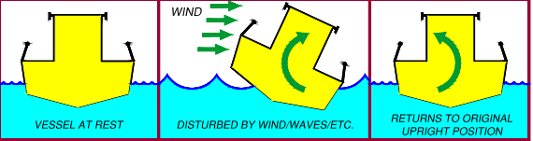

**Figure 3a. Stable**

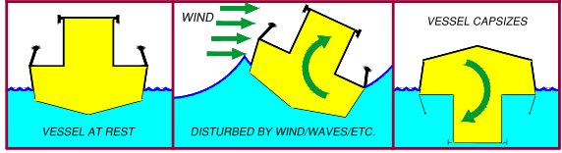

**FIgure 3b. Unstable**

**Detection Test**

A majority of the competition tasks will require the boat to navigate through and around various obstacles. In order to accomplish this, the boat must be able to detect its surroundings as well as the positions of targets. Detection tests will be conducted by placing several buoys in a water setup similar to Figure 4. The boat’s lidar and gps system will be used to locate specific buoys so that it may travel through or around them. Each trial run will be timed.

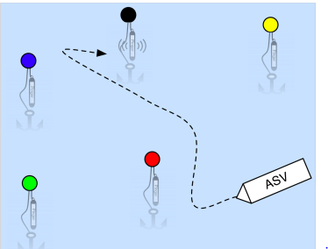

**Figure 4. Buoy Set-Up**

**Thrust Test**

Thrust is a static measurement that determines how powerful a motor is. At the beginning of the competition, the boat will have both weight and thrust measurements taken. The thrust of the boat will be measured by attaching it to a thrust measurement system that is similar to the one shown in Figure 5. The boat will then generate as much thrust as possible for 10 seconds. This task can be accomplished in a manned manner (i.e remote, laptop or buttons on the boat to start/stop this task). A similar strain gauge system will be replicated by our team for the practice trials.

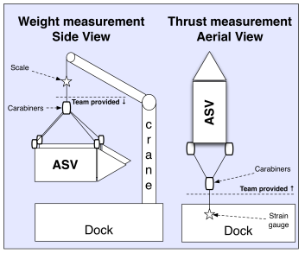

**Figure 5. Weight and Thrust measurement Systems**

# 

# **Discussion of Measurements**

The tools that we will need to utilize in order to validate our design are water, lidar/GPS, propellers, a stopwatch, strain-gauge system, weight measurement system (like a scale), and tools for measurements (measuring tape, yard stick, meter stick, etc.). We will need to use a body of water in order to conduct a stability test during the following weather conditions: rain, wind, waves. Conducting this test will allow us to observe what the best boat design is going to be in unknown weather. The next tool we will need to test is a lidar and GPS system. This will help us be able to navigate through and around various buoys. We will execute a detection test in order to implement what lidar and GPS system performs the best. We will also use a GPS verification system so that we can make sure our GPS reads right. The next tool we will need to validate our design is a propulsion system (thruster/propeller). Using a thrust test will tell us how powerful the motor is. The next tool that will help us with the design process is a strain gauge. This will be used to measure the deformation of where the propellers are connected to the boat. With the deformation recorded the thrust will be calculated from this device. Next we will use a weight measurement system. This will help us ensure that our boat will stay under 140 pounds once all the parts are placed into order. Lastly, we will use a measurement tool (such as a tape measure, ruler, yardstick, meter stick, etc.) to make sure our boat will fit within the prescribed dimensions. We will conduct tests prior to competition in order to find and implement the best equipment relative to our needs and competition.

# **Targets and Metrics Summary**

The targets and metrics were derived using a number of resources including component specification sheets, goals based on previous competition performances, the electrical engineering senior design team, and advisor recommendations. Metrics were created as something to measure a specific function by, and then targets were created based on these metrics. This was done using each function of the functional decomposition to be sure that all targets and metrics were covered. It was decided that the critical targets were Maintain Stability, Detect Surroundings, Process, and Move Boat. Table 4 describes all of the targets and metrics with their corresponding functions.

|  |  |  |
| --- | --- | --- |
| Function | Metric | Target |
| Maintain Stability | Buoyancy | Positive buoyancy for >= 30 minutes |
| Weight Distribution | Center of Gravity below Center of Buoyancy |
| Detect Surroundings | Sensor Range | 6 meters |
| Sensor Speed | Value from spec sheet |
| Detect Position | Sensor Accuracy | Within 14 cm |
| Sensor Speed | Value from spec sheet |
| Communicate | Receive Input from Remote Control | Same as Sensor Speed |
| Send Signal to Processor | Same as Sensor Speed |
| Send Interpreted Data to User | Same as Sensor Speed |
| Process | Object Detection | Same as Sensor Speed |
| Send Instructions to Thrusters | Same as Sensor Speed |
| Interpret Signals from Sensors | Same as Sensor Speed |
| Determine Current Position | Same as Sensor Speed |
|  | Detect Status of Kill Switch | Same as Sensor Speed |
| Safeguard | Kill Switch | If the kill switch is activated, then the boat loses power. |
| Move Boat | Thrust | 13-18 lbs. |
| Power | Energy Supplied | Up to 60 Volts (decided by the electrical group) |
| Visual Signal | Colored LED Lights | One color signifies autonomous mode, one color signifies remote-controlled mode. |
| N/A | Test hull designs in software or air tunnel and see how the flow acts on the design. | Low Drag in Water |
| N/A | Use a stopwatch in tandem with on-board programming controlling thrusters. | Low amount of time to reach operating velocity from rest. |
| N/A | Use a stopwatch to check how long the startup time takes. | Low start-up time. |

**Table 4. Summary of Targets and Metrics**

# 

# **Concept Generation Introduction**

The task of a designer is to find the best possible solution to a particular task. The goal for the RoboBoat design team is to find the best solutions to the challenges of the 2021 RoboBoat competition. The RoboBoat team, using concept generation methods, quickly generated concepts and evaluated the viability of RoboBoat concepts. 100 concepts were generated and evaluated, then narrowed down to 5 medium-fidelity concepts.

# **Concept Generation Tools**

The morphological chart was made by examining the functional decomposition and finding means of accomplishing each function. The morphological chart allows us to see many design combinations quickly, by showing a range of components and possible combinations of said components. We found components through evaluation of previous RoboBoats and research of systems that already accomplish some of our sub-function goals.

|  |  |  |  |  |  |  |  |  |
| --- | --- | --- | --- | --- | --- | --- | --- | --- |
| **Navigation** | **Propulsion** | **Boat Material** | **Control Panel Location** | **Hull** | **Battery Location** | **Vision System** | **Hardware** | **Receiver Location** |
| ROS | Jet Turbine | Carbon Fiber | Inside | Cathedral | Inside | Go-Pro | Arduino | Top |
| Lidar | Propellor | PVC | Front | Catamaran | Top | Sony RX0 II |  | Front |
| Sonar | Fan | Wood | Back | Trimaran | Back | SeaLife DC 2000 |  |  |
|  | Thruster | Fiberglass |  | Pontoon |  | DJI Osmo Action |  |  |
|  |  | Alumunium |  | V-bottom |  |  |  |  |
|  |  |  |  | Flat- Bottom |  |  |  |  |

**Table 5: Morphological Chart**

# **Medium Fidelity Concepts**

**Concept 1**

From Appendix B-Concept 1, we can see the configuration of Concept 1. Concept 1’s use of a Catamaran hull allows for more stability and thus more options on component placement. The hull material is strong but light-weight, being made of carbon-fiber, and is reinforced to prevent leaks from manufacturing errors using flex-seal. The 3 Out-Board differential propellers allow for increased mobility and more overall control. The LiDAR is placed on the top of the RoboBoat to allow for increased visibility, with the GPS being located within the acrylic electronics enclosure. The boat is battery-powered and placed low in the hull to ensure a lower center of gravity. The electronics enclosure is cooled by using an intake to outtake fan setup, to ensure fresh cool air is being cycled throughout the enclosure. The perspective view of the boat is seen in Figure 6, but the other sketches of Concept 1 can be found in Appendix A. One con of this design is the cost, being made of carbon-fiber and coated with flex seal can get quite expensive. Another con is that in inclimate weather (rain, snow, fog, etc.) can disturb the LiDar readings. Another con is that the boat uses active vents, which will use more power from the source that could be better utilized.

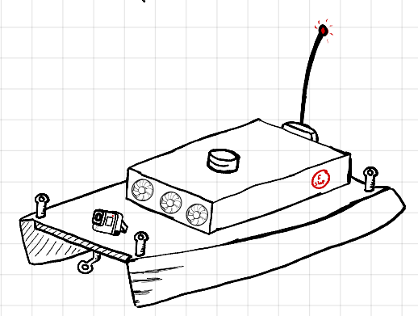

**Figure 6: Concept 1 Perspective View**

**Concept 2**

From Appendix B-Concept 2, we can see the configuration of Concept 2. Concept 2’s use of a Tri-Hull results in added stability. This also means that we have more freedom for placing components on the boat. The hull is made of Fiber-Glass, which is heavier than some other materials used for boat hulls. This means that the boat will not be easily pushed around by waves and wind. The boat will be coated with paint, however over time the paint could begin to chip, crack, or fade. The boat would most likely have to be repainted eventually. The boat will have 3 outboard motors, two differential propulsors in the rear and one stationary propulsor close to the front. This results in better control and maneuverability. The boat will use an ultrasonic device placed at the highest point for object detection to help with navigation. There will also be a GPS device used for localization. The boat will use a bluetooth signal to communicate with the remote control, with the receiver also being placed at the highest point on the boat. The boat will also be battery powered with the battery being placed close to the rear of the boat with most of the other components. There will also be a visual feedback camera located near the front of the boat so that we can get an idea of what the boat sees when it's on the water. Most of the electronic components will be held within an enclosure made of plastic (PLA). This is good because the plastic material is waterproof and we do not have to worry about harming the components if it gets wet. The cooling system will consist of a vent in the front of the box and a fan in the back of the box to pull cold air over the electronic components. There will be a tow harness located in the front of the boat since this will make it easier if it is being towed in the same direction it is designed to move in. There will also be a point for the deployment harness at each corner of the boat to ensure proper balance during deployment. The perspective view of the boat can be seen in Figure 6, while the other views of the boat can be found in Appendix A.

One of the cons of this concept is the price. Some of the components and materials could become expensive. Also, LiDAR signals can be interrupted by rain, snow, smoke, or anything else in the air that could get in the way of the laser beam coming from the LiDAR sensor. Another con is the fact that the cooling system has a passive intake, meaning that it is not pulling air into the electronics compartment but pushing air out. However, this could help avoid sucking water into the electronics compartment. Also, if the visual camera is not waterproof it could become damaged if the front of the boat tips into the water.

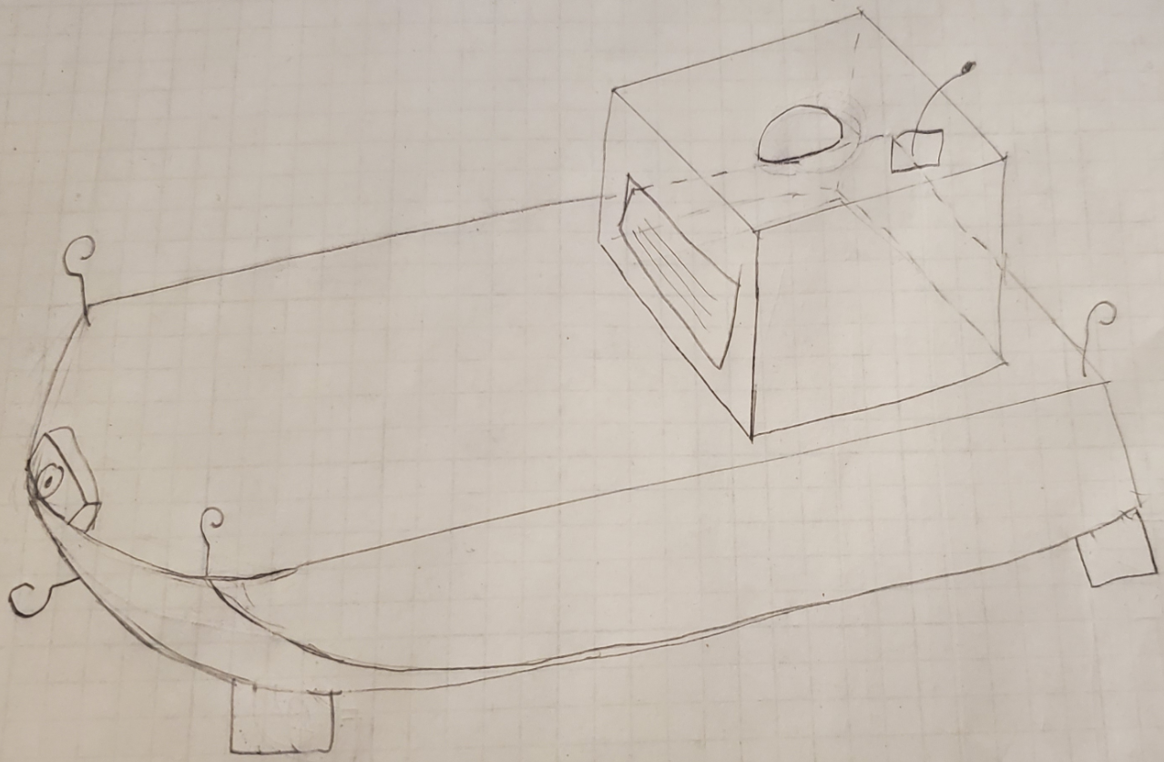

**Figure 7: Concept 2 Perspective View**

**Concept 3**

Referring to Appendix A-Concept 3 the perspective, front, back, top, bottom, and cross sectional views are available. Shown in this section is the perspective view for Concept 3. This concept utilizes an aluminum, flat bottom boat sealed with flex seal. This boat uses two pivoting inboard propellers that allows for maximum maneuverability. Mounted to the front of the boat is a lidar sensor used to detect objects. We will use a GPS system for our localization system. We will also use radio for our remote control signal with our antenna receiver located on the back of the boat. This boat will use a battery to power it located in the interior hull. The camera will be mounted on top of the wooden electronic enclosure. The wood electronic enclosure will use an intake and outtake vent to passively cool the electronics. The tow hook is located on the belly of the boat. Lastly the boat will have 4 deployment harness hooks located at each corner of the boat. The features mentioned above will be listed below in appendix B. One of the pro’s to this design is the aluminum hull. Aluminum is a lightweight, durable metal that will be able to tackle any obstacle thrown at our way (for our RoboBoat needs). Another pro is that with the swiveling propellers, the boat will be able to have maximum maneuverability. Lastly with the LIDAR sensor in the front, it will position the sensor to detect objects the best. However, one con of this design is the hull shape (flat bottom boat). This particular design can be hard to maneuver because of the lack of drag. The next con is the hull material, aluminum. Aluminum can be very expensive, resulting in us possibly going over budget. Lastly, the wooden electronic enclosure box could allow the electronics to get wet if not sealed properly. If the electronics get wet, our electronics on board would be fried.

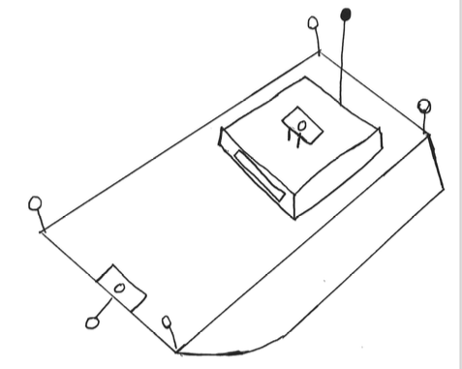

**Figure 8: Concept 3 Perspective View**

**Concept 4**

From Appendix B-Concept 4, the use of a pontoon shaped hull provides boat stability and spacious storage area for the required payloads and electrical components. The hull will be made out of wood and coated with epoxy resin. Epoxy resin will provide moisture resistance and increase the fatigue strength of the boat. A disadvantage of the hull shape would be that it requires a large turning radius therefore, it will struggle to make tight turns. The propulsion system will have 3 outboard motors, two differential propulsors in the rear and one stationary propulsor in the front so that it is maneuverable in the water. The boat will utilize a LiDAR for object detection and a GPS device for navigation.Although LiDARs are inexpensive, low hanging clouds and heavy rain can cause them to be inaccurate. A Bluetooth will be used to communicate with the remote control, and a receiver will be placed in the front of the boat. The boat’s battery and electrical components will be enclosed in a plastic box. These components will be housed in the lower compartment found in the center of the boat. Also, a GoPro camera will be placed in the front of the boat to provide visual data. The cooling system will consist of a vent on the boat’s wall and a fan will be mounted above the electrical components so that they can continuously be blown with cool air. A tow harness will be mounted in the rear of the boat and a hook will be mounted in each corner for the deployment harness. A four point deployment harness will keep the boat balanced any time it is deployed. The perspective view of the boat can be seen in Figure 19, while the other views of the boat can be found in Appendix A.

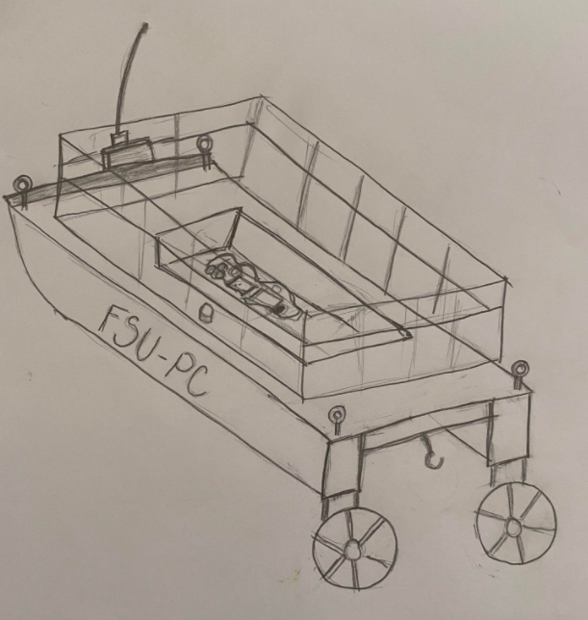

**Figure 9: Concept 4 Perspective View**

**Concept 5**

From Appendix B-Concept 5, we can see the configuration of Concept 5. The V-bottom hull shape allows for the boat to cut through the water with a lower contact surface between the hull and the surrounding water. The fiberglass composition of the boat hull will limit the amount of distance that the boat could be unintentionally moved by water currents, while the hull design allows for a wide weight distribution which will help the boat maintain buoyancy. The boat will be coated with a hydrophobic spray to reduce the friction caused when the boat is moving through the water. It will also help ensure that the insides of the hull are dry, and the electrical components housed within the hull will not suffer water damage. The boat will have 2 differentially steered motors found on the rear side of the boat. This will allow for precise turning and maneuverability. The LiDAR will be placed near the front of the boat to allow for accurate distance measurements. It will be accompanied by a camera used for data collection and to give us a way to ensure accuracy from the perspective of the boat itself. Localization will be managed by a GPS located within the boat. Most of the electrical components will be housed in a plastic (PLA) box found within the hull, this will ensure that the components are safe from water exposure in the event of water breaching the hull while being lightweight and accessible. There will be 2 vents found on the front of the boat to allow for airflow through the hull to keep the electrical components from overheating. They will be accompanied by 2 fans blowing outward on the back side of the boat to ensure the air doesn’t become stagnant inside the hull. A perspective view can be seen in Figure 10 while other views can be found in Appendix A . The V-bottom hull allows for a higher speed, but suffers from a lower stability for tight turns. The sensors are sensitive to disturbances and may be inaccurate if used in suboptimal weather conditions. The vents being used as a passive intake may not give enough airflow over the electronic components to sufficiently cool them down while in use.

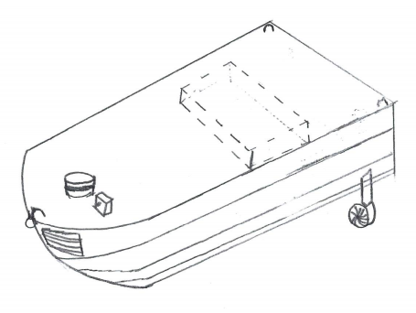

**Figure 10: Concept 5 Perspective View**

# **100 Concepts**

**Hull Shape**

1. Displacement Hulls
2. Cathedral
3. Planing Hulls
4. Flat Bottom
5. V-Bottom
6. Tri-Hull (Tunnel Hull)
7. Pontoon
8. Semi-Displacement Hulls
9. Multi-Hulls
10. Catamarans
11. Trimarans

**Hull Material**

1. Carbon-Fiber
2. Fiber-Glass
3. Aluminum
4. Stainless Steel
5. Rubber
6. Plastic (PLA)
7. Plastic (ABS)
8. Wood
9. Titanium
10. PVC (Polyvinyl chloride) Pipe
11. Ferro-Cement
12. Polyethylene foam
13. Flex-tape
14. Flex-Seal
15. Aero-Gel

**Hull Coating**

1. Gel
2. Hydrophobic Spray
3. Seamless Polyurea
4. Ceramic Coating
5. Paint
6. Epoxy resin
7. Flex-Seal
8. Flex-Tape
9. Polyurethane
10. Varnish
11. Lacquer
12. Galvanize
13. Powder Coating
14. Penetrol

**Propulsion**

1. Inboard Propeller
2. Outboard Propellor
3. Fan
4. Sailboat
5. Rowing

**Propulsion Amount**

1. 1 propulsor
2. 2 propulsor
3. 3 propulsors
4. 4 propulsors
5. Differential propulsor
6. 2 Differential propulsors
7. 3 Differential propulsors
8. 2 Differential propulsors + 1 propulsors
9. 2 Differential propulsors + 2 propulsors
10. 4 Differential propulsors

**Object Detection Sensor**

1. Ultrasonic
2. InfraRed
3. LiDAR
4. Time of Flight
5. Camera/Image processing

**Object Detection Sensor Position**

1. Front
2. Top
3. Rear

**Localization**

1. GPS
2. Odometer & Gyroscope
3. Triangulation

**Remote Control Signal**

1. BlueTooth
2. Radio
3. Ethernet cable
4. IR signal

**Receiver Location**

1. Front
2. Top
3. Rear

**Power Source**

1. Steam Power
2. Gas Power
3. Solar Power
4. Wind Power
5. Battery Power source

**Power Source Location**

1. Front
2. Top
3. Rear
4. Interior Hull

**Visual Feedback Camera Location**

1. Front
2. Top
3. Rear

**Electronics Enclosure**

1. Yeti enclosure
2. Wooden
3. Acrylic
4. Cardboard Box
5. Carbon-Fiber Box
6. Plastic Box (PLA)
7. Plastic Box (ABS)

**Cooling System**

1. Fans (active intake) + Fan (active outtake)
2. Vents (passive intake) + Fan (active outtake)
3. Fans (active intake) + vent (passive outtake)
4. Vents (passive intake) + vents (passive outtake)
5. Liquid cooling
6. Mineral Water

**Tow Harness Locations**

1. Front
2. Rear
3. Side
4. Corner
5. Belly of the boat

**Deployment Harness Locations**

1. 3 point harness: 2 hooks in the front, 1 in the rear
2. 3 point harness: 2 hooks in the rear, 1 in the front
3. 4 point harness: 1 hook in each corner

# **Concept Generation Conclusion**

Fidelity refers to the amount of detail a prototype contains. After brainstorming, the RoboBoat team was able to generate 5 medium fidelity concepts using a morphological chart. Although each concept has its disadvantages, the selected 5 were still the best options for a final prototype.

# **Concept Selection Introduction**

The FSU-PC design team was tasked with constructing an autonomous boat for the 2021 RoboBoat Competition. Thus far, we have generated a function decomposition diagram from the interpreted customer needs and competition requirements, devised important targets and metrics, and produced a morphological chart that led to the generation of 5 medium fidelity sketches for a possible boat design. The final concept selection was achieved through the following processes: Binary Comparison Chart, House of Quality (HoQ), Analytical Hierarchy,Pugh Chart, and a final Decision Matrix.

# **Binary Comparison Chart**

A binary comparison chart is used to compare customer requirements one by one to decide how important they are with respect to other customer requirements. However, when comparing requirements, they are not given weighted values at first. It is simply determined whether one requirement is more important than the other. After all requirements have been compared, the totals are taken to find the appropriate weighting for the requirements. These weightings are then used in the house of quality chart for the importance factor.

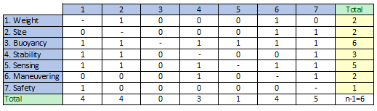

**Table 5: Binary Comparison Chart**

# **House of Quality (HoQ)**

The House of Quality is used to relate our customer needs to engineering characteristics to determine priority. Using the importance factors found by the binary comparison chart, we can directly compare how our engineering requirements will relate to our customer needs. This allows us to focus our attention on characteristics that will more heavily impact the ability of our final design to meet our found customer requirements.

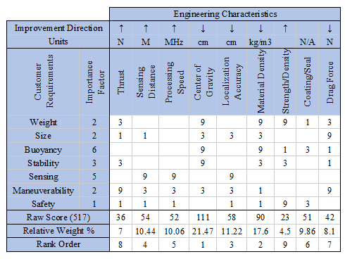

**Table 6: House of Quality**

Each engineering characteristic is compared to the given customer requirements and rated based on a scale of 0,1,3,9 for how related they are, with a 0 having no correlation and a 9 having a high correlation. By doing this comparison we were able to determine that our most influential characteristic is the center of gravity, which will heavily impact the stability and buoyancy of our final design. This also finds that the least impactful characteristic is the coating, which will directly affect how the boat will interact with the water but is not as influential to the success of the final design as the other listed characteristics.

# **AHP**

The AHP chart is used to compare how much more important the row is versus the column, or vice versa. To do this, we assign either a 1, 3, 5, 7, or 9 to whatever is more important, depending on level of importance. 3 low on importance and 9 being a higher importance. This is read as “row compared to column”.The only time a 1 is used is when the same two categories are compared to each other, or two categories are very similar. Once we declare the importance level between two categories with either a 3, 5, 7, or 9. We write the inverse of the whole number when they are compared again (every category will be compared twice in different orders). Once the chart is filled out, all the scores are added up and recorded on the SUM row at the bottom. Using the categories in the respective column, the column with the lowest sum results in being the most important while the column with the highest sum results in being the least important. The order from most to least important characteristics are: Maneuverability, Reliability, Reparability, Hull Design, Cost, Hull Material, and Speed.

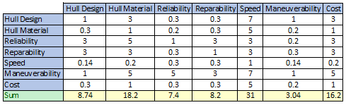

**Table 7: AHP**

**Normalization and Criteria Weight**

Figure 13 shows the Normalization and the Criteria Weight. The normalization is found dividing each cell by the sum of the column it is in. Once each cell is calculated, all the cells should add up to be 1. Also the Criteria Weight column is all the values of each row averaged out. The sum of these should also come out to equal 1.

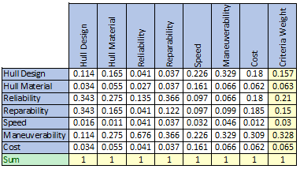

**Table 8: Normalized AHP**

# **Pugh Chart**

A Pugh Chart is a tool used to evaluate multiple options of a design against each other. A baseline is used to compare to an existing or proven concept. Values found using the House of Quality and AFP were used to find how we would determine which concept was best based on the Pugh Chart.

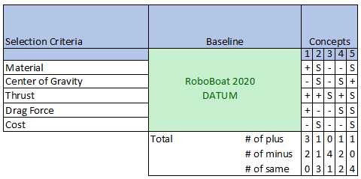

**Table 9: Pugh Chart**

The datum used for the Pugh Chart is the 2020 FSU PC senior design teams concept, we compared it to their design to see if our new concepts would be better or improve their design. The material selection criteria was to determine which material had the best strength ratio (Figure 15), which was measured by taking the tensile strength and dividing it by the density. The center of gravity (CG) was analyzed by observing the component placement on each type of hull and estimating the CG location. The thrust force is related to the weight, drag, size, and amount of power we have supplied to the thrusters, to measure this we made assumptions to simplify the problem. The assumptions suggest that thrust is greater with lighter boats, and more thrusters distributes power evenly (making the total amount of thrusters generate the same thrust but can maneuver the boat more easily). The drag force of the boat was evaluated based on the hull shape and size of each concept. We considered that we would be moving more slowly through the water so boat hulls like the flat bottom and v-hull would not benefit from high speed planing effects. The cost of the boat was mainly evaluated based on the assumption that the GPS system is the system used from the RoboBoat club (same for each design), the LiDAR system is the same for each design, and that the electrical engineering side would be handling the battery. This left the material as the main cost consideration, therefore it was evaluated based on the cost to strength ratio of each material (Figure 15).

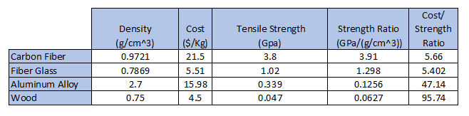

**Table 10: Material Characteristic Comparison**

Based on the Pugh Chart we found that the first concept was the best choice, with 3 of the selection criteria being better than the datum and 1 being worse than the datum.

# **Decision Matrix**

The Decision Matrix was used to determine if our concepts are feasible based on data found in the Pugh Chart.

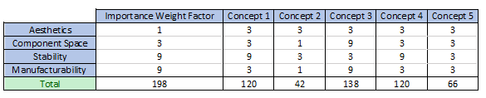

**Table 11: Decision Matrix**

The decision matrix found that Concept 3 was the easiest to manufacture and would have the most space for our components. Although considering the benefits found from the pugh chart, AHP and HoQ, it is determined that it would be worth the more difficult manufacturing to have the catamaran design. Therefore we acknowledge that it will be more difficult to manufacture, but will be pursuing the catamaran.

# **Final Decision**

Therefore based off of the concept selection tools it is deemed that concept 1 would be the best design to pursue. There should be some modifications that will occur during the future design phase of the project, as one issue found with this concept is that the CG may need to be corrected based on component placement. It was also found that it would be worth it to use fiberglass for this design over carbon fiber as it is more cost effective for its strength and weight. It will use 3-4 differential thrusters to ensure good maneuverability in combination with high thrust.



**Figure 6: Perspective View**

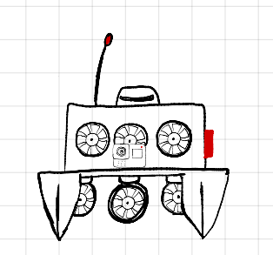

**Figure 6 Additional View: Front View**

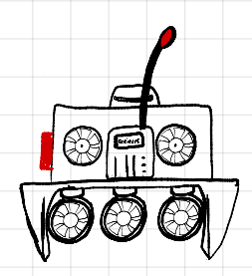 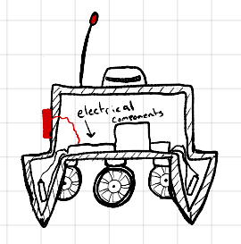

**Figure 6 Additional View: Rear View Figure 6 Additional View: Cross-Section View**

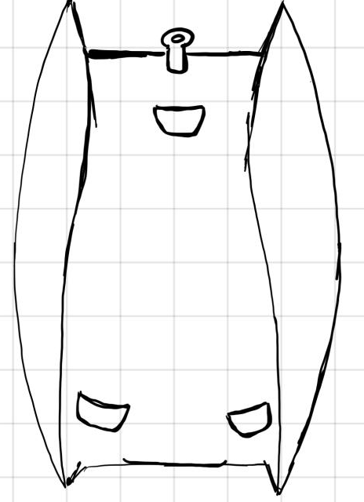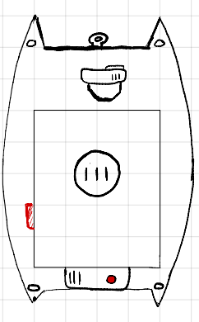

**Figure 6 Additional View: Bottom View Figure 6 Additional View: Top View**

# **Bill of Materials**

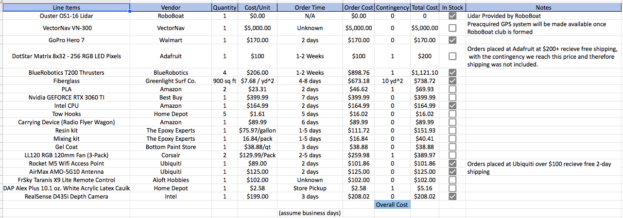

**Figure 11: Bill of Materials**

# **Prototype Plan**

The RoboBoat team will be making multiple prototypes that will help to finalize the final design of our boat.

## **Hull Prototypes**

The hull prototypes will consist of making CAD models of the hull with slight variations in the design (flat front versus a pointed front, wide pontoons versus thin pontoons, etc.). We will then run the models through flow software to find which designs are best. After narrowing down the designs to a couple of models, we will make small-scale hull models to see how it would sit in the water and use weight (that is the scaled-down equivalent of our components) to see how the boat sits in the water with different component placements. These models would be constructed by 3D printing the CAD models we narrowed down and using them as a mold for a hand layup of fiber-glass. The cost of the prototypes would be around $20-$60 in PLA Filament (depending on the infill and support requirements), and the fiberglass cost would be around $24 at $8 per 30” x yard. By teaming up with the Digital Design Studio (DDS) at FSU PC we can bring the PLA cost to $0. The 3D printing process and fiber-glass layup will take the most amount of time for this prototype, although with the amount of 3D printers the DDS has we are able to cut that time dramatically down. Total max cost ($84), Total min cost ($24).

## **Software Prototype**

The software prototyping will be handled by the Electrical Engineering Senior Design team.

# **Assessment Plan**

Testing on the prototype will be carried out in various forms. One form of testing will be completed using a flow simulator to compare the aerodynamic characteristics of each of our models. We will also be putting the models in water to test their buoyancy and how they sit in the water, as well as how component placement affects the prototypes. This will then be used to determine how to place components on the final product.

Our critical targets include maintaining stability, detecting surroundings, processing, and moving the boat. Our metrics for maintaining stability are buoyancy and weight distribution. We aim to have a positive buoyancy for at least 30 minutes, and we want to make sure the center of gravity is below the center of buoyancy. Our metrics for detecting surroundings are sensor range and sensing speed. This will be tested using Solidworks software. We want the sensor range to be 6 meters, and the sensing speed will be 20 Hz. The metric for processing is object detection and will have a target of 327,680 points per second. The metric for moving the boat is thrust, and we aim to have between 13 and 18 lbs of thrust.

The results gathered from the assessment tests will be used to update our design and ensure that our critical targets will be met. These results will be used to make changes to our hull design and increase the functionality of our written code. Changes to the hull design include reshaping of the hull, updating the weight distribution of internal components, as well as changing the thruster orientation and positioning. The code will be rewritten as needed to quicken the processing speed and remove any unnecessary code.

# **Risk Assessment**

The RoboBoat team evaluated the risks involved with future work to be done on the project. We evaluated manufacturing, wiring, testing and transportation.

## **Manufacturing**

The boat will be manufactured at the High Performance Materials Institute, (HPMI) at the FSU Tallahassee campus. The process will consist of 6 steps; the mold, fiber-glass layup, vacuum sealing, curing, sanding and coating the boat hull. The main risks are lacerations, breathing hazards, skin irritation/inflammation, and eye irritation/inflammation. The risk will be minimized as the HPMI professionals will be able to help with the process.

## **Wiring**

The wiring consists of 3 parts, connecting components (motherboard, cpu, gpu, LiDar, etc.), connecting the batteries to the system, and any soldering that is needed. The main risks are burns, fumes, dropping components on feet or other limbs, and electrocution.

## **Testing and Transportation**

Final product testing will consist of having an autonomous boat, that will have to make its own decisions and if all goes wrong and the remote-control feature fails then possible harm to the testing team may occur. The risks may include lacerations, colliding with the boat, and getting dragged by the boat. The risks with transporting the boat may include dropping the boat on feet/limbs, slipping, injury by lifting, lacerations, entanglement. The driver of the vehicle for transport also assumes the risks that come with operating a vehicle.

## **Risk Mitigation**

The risks will be mitigated by wearing proper personal protective equipment (PPE), such as closed toe shoes, masks, goggles, gloves, long sleeve shirts and pants as well as using ventilation for the fumes. We also will have fire extinguishers and have first aid kits on hand, and if the situation becomes drastically worse, emergency services will be contacted.

All documents relating to risk management can be found in figures 18 through 23.

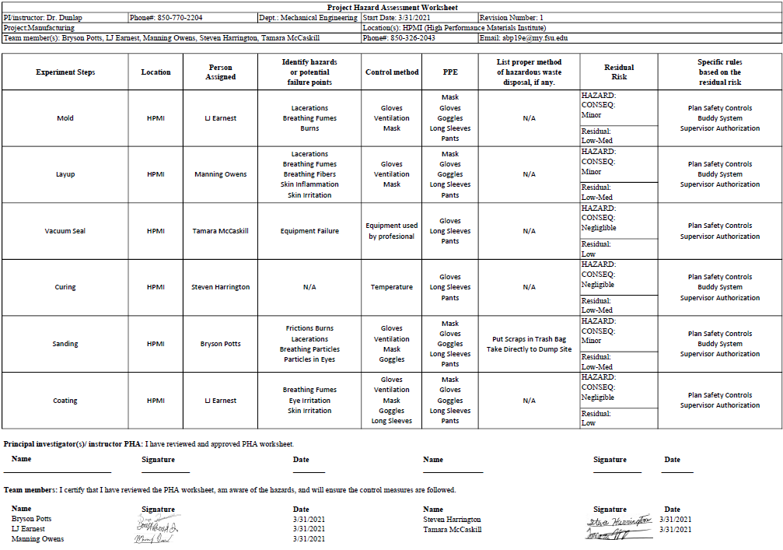

**Figure 12**

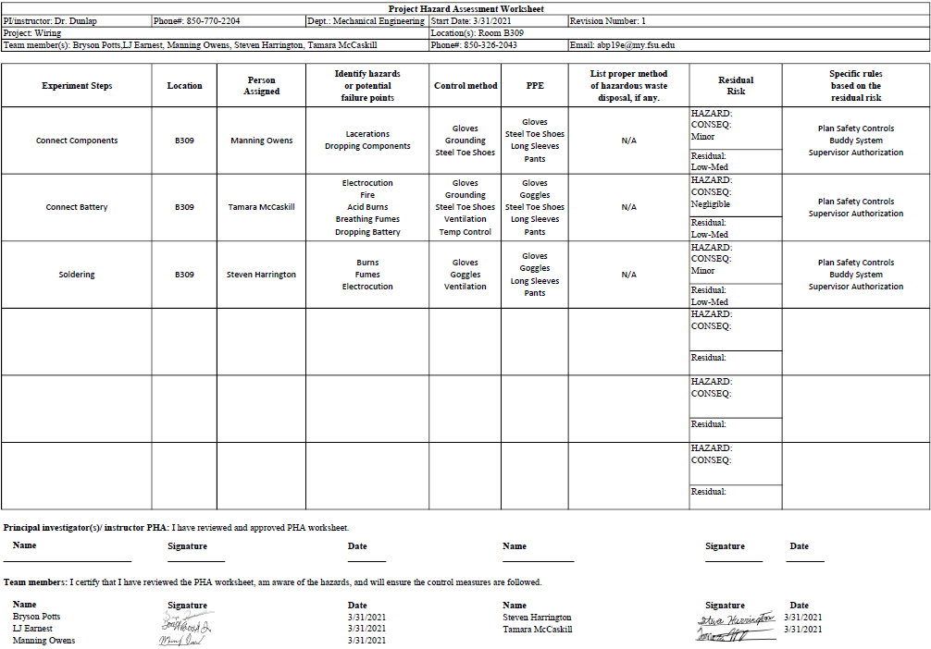

**Figure 13**

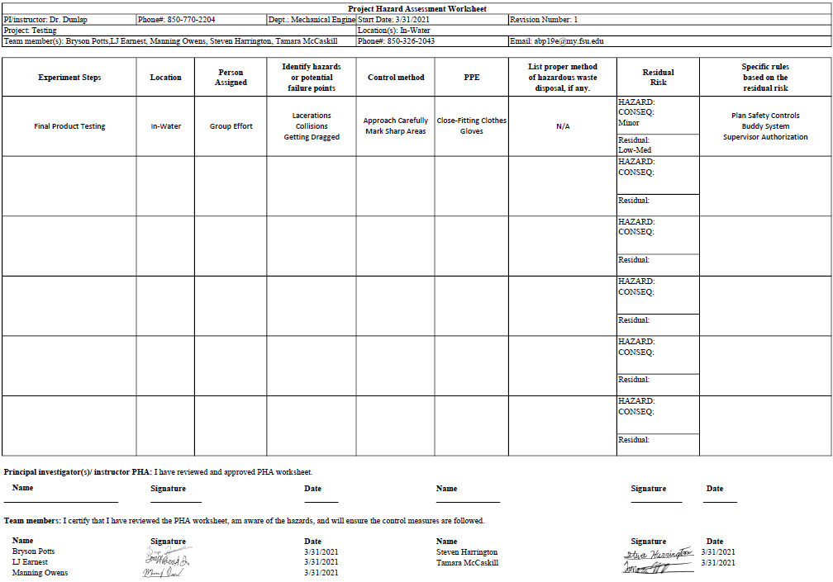

**Figure 14**

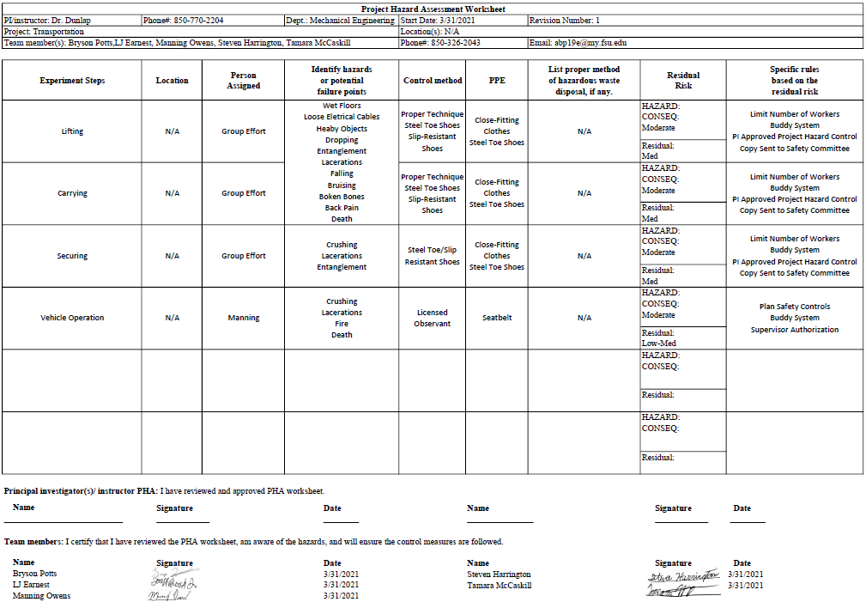

**Figure 15**

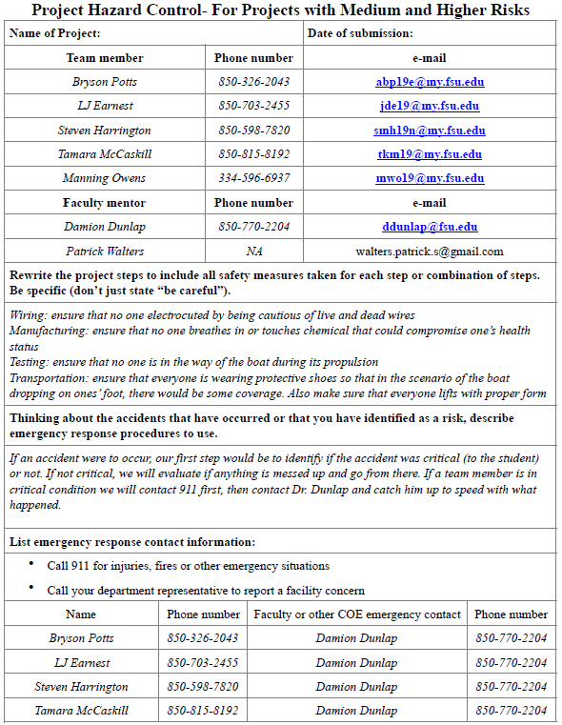

**Figure 16**

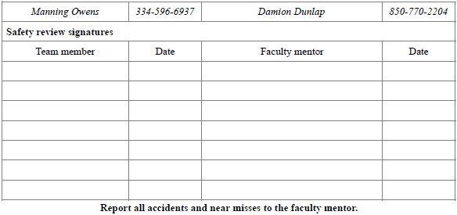

**Figure 17**

# **Restated Project Charter**

# **Mission Statement**

Our mission is to demonstrate skills acquired through FSU-PC’s mechanical engineering program by constructing a boat that is capable of meeting the 2021 RoboBoat competition standards.

## **Team Roles**

**Team Lead - Bryson Potts**

The team lead focuses on the overall production of the project and is knowledgeable in all areas of the project’s requirements.

* Main point of contact with advisor/sponsors
* Oversees the entire project to make sure that all areas are covered
* Ensures that everyone understands what they are doing

**Secretary - Tamara McCaskill**

The secretary maintains group organization.

* Records meeting minutes
* Reorganizes throughout the project as necessary

**Builders - Manning Owens, Steven Harrington, and Tamara McCaskill**

The builders focus on the physical design, fabrication and assembly of the project. These components include:

* Material Selection
* Hull Design
* Construction and Fabrication
* Propulsion Design
* Weight Distribution

**Subsystem Designs - Bryson Potts, Joseph Earnest**

The Subsystem Designer will build prototypes in modeling software and physically to test the reliability and functionality of the design to ensure final product reliability.

* Test and build subsystem prototypes
* Improve said prototypes

Additional project related tasks will be assigned based on team member availability.

## **Communication Policy**

University emails, official communications, and outside resources, including but not limited to: Google Documents, Zoom, WhatsApp and Basecamp, will be used as methods of communication. Scheduling meetings and assigning work will occur through WhatsApp, any conflicts to completing assignments or attending meetings should be stated at least 24 hours in advance via WhatsApp. File sharing will occur through either Basecamp, Google Documents, or via preferred email address. It is the sole responsibility of each member to receive such communications and to respond as needed within 24 hours.

## **Dress Code Policy**

Policy Statement:

All Clothing must be in good taste and conducive to the function. Roboboat members will wear business attire for presentations/sponsor interactions and casual attire for team meetings.

Business/Professional Attire:

Members should choose business attire such as dresses, pants, shirts, blouses, dress shirts, ties, suits, and skirts. Open toe shoes and sandals are not allowed

Casual Attire:

Members should choose casual attires such as jeans,shorts and any other relaxed clothing for everyday wear. Open toe shoes and sandals are allowed.

## **Attendance Policy**

Attendance policy overview.

Participants in the RoboBoat group are expected to be present and on time for all scheduled project meetings and work. Being tardy or absent should be minimized as it causes disruptions and burdens colleagues.

Attendance infractions.

A point system will be used to track infractions and tracked via WhatsApp.

1. Notified absence sent via WhatsApp or Basecamp: 0 point.
2. Unnotified absence: 1 point.
3. Tardy (more than 30 minutes): ½ point.

Overview of disciplinary action for attendance infractions.

After a team member has accrued a certain amount of points from infractions the following disciplinary actions will occur.

3 points: Verbal warning.

4 points: Corrective counseling with an advisor.

5 points: Termination/Removal from the group.

Attendance policy exceptions.

Absence because of illness, jury duty, injuries, or other notified unforeseen circumstances are exempt from disciplinary action.

## **Code of Conduct**

The RoboBoat team will

1. Carry out their responsibilities in a timely manner, with notice of delays.
2. Practice honesty and integrity to the trust placed in completing work.
3. Be respectful to other members.
4. Openly share information and cooperate with peers in discussions and meetings
5. Be present for all meetings with prior notice of delays or absences.
6. Abide by the principles established in this code

## **Project Description**

Our boat will hold the capability of being able to be controlled by a wireless remote controller. We will be using a catamaran hull design that is made out of carbon fiber.

## **Key Goals**

The key goals of this design project are:

* Construct a maneuverable, buoyant, stable boat for EE to implement components on
* Construct a LiDAR tilting mechanism
* Construct a hot-swap propulsor system

## **Market**

The market for this project includes the companies that attend the competition scouting for potential employees based on the technical skills demonstrated, and companies that focus on autonomous maritime development. Some of these companies include:

* Office of Naval Research
* SolidWorks
* NVIDIA
* Velodyne Lidar
* Siemens
* Mathworks

## **Stakeholders**

Stakeholders are the Individuals and Organizations who want the project to be successful. Some of these include:

* Project Advisor
* Dr. Damion Dunlap
* Florida State University Administration
* Florida State STEM Department
* SPEAR club
* Independent RoboBoat Club Donors
* RoboBoat Senior Design Team

## **Assumptions**

* Any monetary need is funded
* Any need for tools and manufacturing is available
* Manufacturing materials will be provided by Gulf Coast
* The Electrical Engineering Team will be handling all coding and power components
* A fully functional boat will be completed before Senior Design Day

## **Statement of Understanding**

(i) I am aware that RoboBoat group’s policies are available to me in the POLICY folder on Basecamp. It is my responsibility to familiarize myself with these policies.

1. In addition, I confirm that I have received, read and understood the following policies:
   * + Mission Statement
     + Team Roles
     + Communication
     + Dress Code
     + Attendance Policy
2. I agree to conduct my activities in accordance with RoboBoat group’s policies and understand that breaching these standards may result in disciplinary action up to and including termination/removal from the group.

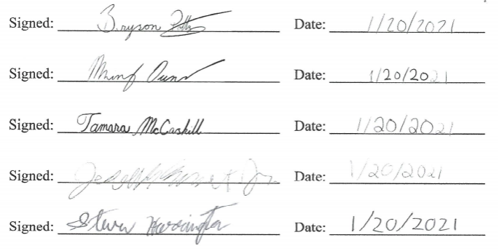

# **Critical Design Review**

## **Introduction**

The goal of our project is to demonstrate the skills acquired through FSU-PC’s mechanical engineering program by constructing a boat that is capable of meeting the 2021 RoboBoat competition standards. Our team will primarily focus on assembling a maneuverable and buoyant boat for sensor integration by the FSU electrical students, constructing a lidar tilt mechanism, and designing a hot -swap propulsion system.

Now that the RoboBoat competition has passed, our priorities have shifted to producing a fully functional boat before the senior design deadline in July. Originally, we planned to manufacture our boat hull in the material’s laboratory at FSU-Tallahassee but due to time constraints, have now decided to do this at Gulf Coast State College. After hull assembly, we will then collaborate with the electrical team to integrate the sensors. Once the boat’s main sensors and propulsion system are mounted, we will begin testing in the lake beside our campus.

# 

## **Revised Requirements**

The scope of our project has changed in response to current progress and our anticipated final product. During the spring semester our group anticipated to enter in the RoboBoat competition as it was presented at the time. After the competition was changed to be remote the requirements for the competition changed, leading the team to prioritize hull design and material selection. Our initial final goal was to have an autonomous boat as per RoboBoat standards. With the current progress made the end goal has changed to reflect a more likely outcome of having a functional, RC capable boat by the end of the semester. Other current goals have remained the same, including putting final touches on the hull design, fabrication of the boat hull, and integration of electrical components into the fabricated hull.

# 

## **Submissions**

For the RoboBoat competition, there were three submissions: a technical design report, a skills video, and a website link. For the technical design report, the mechanical group and the electrical group worked on separate parts. This was so that each group could write about the things they were working on and be able to work independent of the other group. The mechanical portion covered the hull design and the design process. The electrical portion covered the electronic components of the RoboBoat. Since we were still in the prototyping phase of the project at the time the report was written, each team also talked about future plans for the project and how we planned to put together the final design.

For the skills video, the mechanical team decided to talk about the hull design and design process. The advantage of making a video is that it gives the capability to highlight things better suited for verbal demonstration. This way we could use our 3-D printed model of the boat to give demonstrations and reference during explanations. One example of this is when we talked about component placement, we could show how we used lead fishing weights as representative weights in the model to find where we wanted to place components. Another example is when we talked about the hatch in the lid of the boat. We were able to use the model to show how the hatch would work, as well as the approximate placement and size of the hatch.

Our final submission was the website link. For our website, we updated the existing SPEAR website by adding a new page for the 2020-2021 RoboBoat team. We added pictures of teammates and advisors, as well as a render of the RoboBoat design with a description. As the project progresses, we will be adding more to the website to give a more comprehensive view of the project.

## **Current Design Review**

***Hull Design***

We decided to go with a Catamaran style hull. This hull design gives ample storage space for component placement. Because of the available room, we will be able to attach 4 thrusters on the boat (2 along each pontoon). This boat style also gives us optimum stability and sits tall in the water. The 2019 RoboBoat team made a boat with the same hull design. However, they had a couple errors pertaining to their boat. The first thing is that their boat was not long enough resulting in the front of the boat being too light. Also, their thrust force was too much. Therefore, when they accelerated, their boat ended up flipping and not being able to compete. We decided to correct those mistakes in making sure our boat is long enough and will have enough weight at the front. Also, we added 4 thrusters to the boat (2 in the front and 2 in the rear), this allows the thrust force to be distributed more evenly and allow the bow of the boat to not come too far out of the water.

***Hatch Design***

The previous RoboBoat team stressed to us the importance of having easy access to the components inside the boat. In previous years either the whole top of the boat had to be disassembled or there was little room to move around or take out components. Because of this, our team set the hatch design as one of our top priorities.

Essentially, the lid of the hatch sits in a groove on the top of the boat lid and will be sealed with silicone. There will also be latches connecting the hatch and boat hull to hold the hatch down. With these measures in place the hatch should be waterproof and keep the components from getting wet or damaged in the event that the boat gets water on top of it or flips over in the water. The hatch should also be big enough to allow easy access to all components without the need to disassemble the hull.

***LiDAR Tilting Mechanism***

To ensure that the boat senses everything adequately we decided that being able to tilt the LiDAR would be a beneficial endeavor. By tilting the LiDAR we would be able to adjust the sensor on the fly, and be able to use it in the best configuration for our hull design.

***Propulsor Attachment***

In the case of a propulsor failing, how it is attached is an important aspect of how hard it is to fix. We have developed a hot swap propulsor attachment that allows for us to easily change propulsors in the event they fail. A track is mounted to the hull, and the propulsor is mounted to a fin on the track, if the need to change the component arises, we simply slide it off the track and mount a new propulsor.

***Prototyping***

Before finalizing the design with our theoretical values, we decided to make a 3D printed 1/16 volume scale model of the hull. By doing so, it allowed us to see a physical representation of how the full-scale model would float and allow us to scale down our weights and more easily see how component distribution would affect how the boat would float. It was 3D printed out of PLA in three parts, the hull, the hatch, and the hull lid. The scaled down component weights were represented by lead fishing weights at the appropriate scaled weight.

We will also be prototyping the LiDAR Tilt Mechanism and try to recreate/improve the propulsor hot-swap before June 20th.

**Timeline**

Below is a picture of the timeline of our project for the remainder of the semester. It is important to note that an initial prototype will be completed prior to the rest readiness review. Lastly, with the help of the electrical engineers, we will have a final and complete product by the end of the semester (July 30).

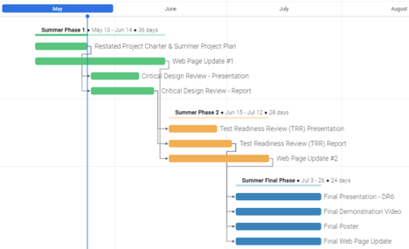

Figure 18: Timeline as of Phase 1

# **Test Readiness Review**

## Project Overview

The goal of our project is to design and build a boat with autonomous function capable of completing the course objectives for the 2021 RoboBoat Competition.

## Project Background

RoboBoat is an international competition hosted by RoboNation in Daytona, Florida. Competitors create autonomous surface vehicles (ASV) to complete simplified tasks. The tasks simulate real world challenges found in the maritime industry such as surveillance, object delivery, and navigation.

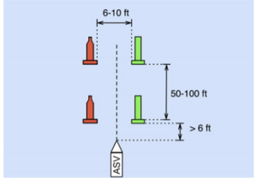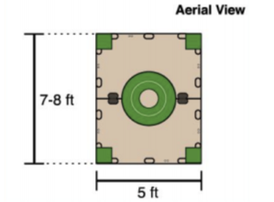

Figure 19: Competition Challenges

As a result of COVID, The RoboBoat 2021 competition was held online. Deliverables that we had to create for the competition were a short skills video, detailed technical report and a team website (<https://pcspear.org/the-2020-2021-team/>).

## Boat Specifications and Status Update

**B.O.A.T Specs:**

-Length is 1.2 meters

-Height is 0.7 meters

-Material of construction is E6 Fiberglass.

-Weight estimate of Hull + Lid is 13.26 Kg or 29 lbs. (SolidWorks material estimate)

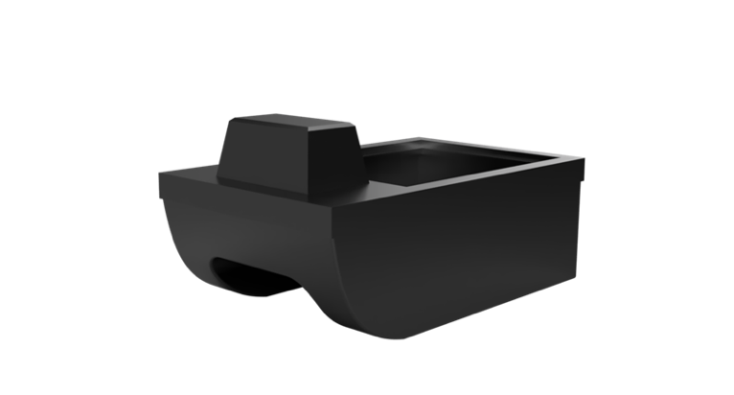

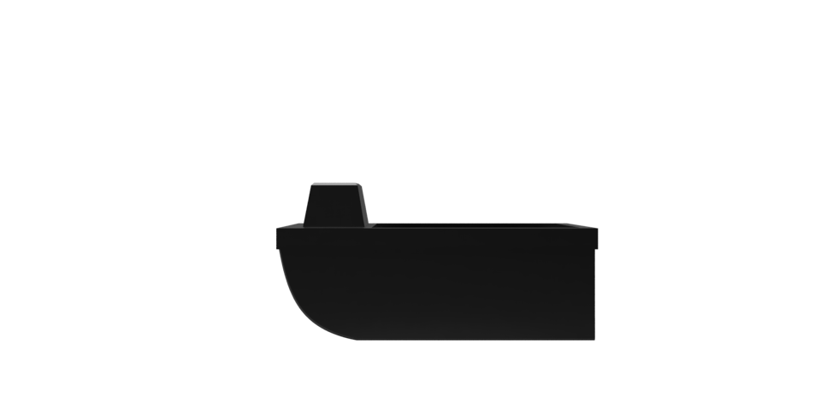

Figure 20: Boat Prototype Model

**Status Update:**

We were unable to manufacture B.O.A.T at Gulf Coast, therefore we had to make a mold and layup B.O.A.T by hand out of fiberglass and epoxy resin. Electronics will be installed on Monday, July 19. Testing will begin immediately after the electronics are implemented.

## Assessment Plan

In our testing one thing we will observe and assess is the floatation of the boat. We will see how it floats, if it can float for at least 30 minutes and it has the desired stability. Concerning the stability, we will see if it sits level and if it flips when and where force is applied. Once the electrical engineers implement all the electronics we will see how well the LiDar system works and the ease of changing out the propellers using the propeller hot swap method we came up with. Lastly, we will observe and see how well the boat performs and if any changes/tweaks need to be made.

The table below shows the order of the test, and the targets/metrics that are associated with each.

|  |  |  |
| --- | --- | --- |
| Test | Target | Metric |
| Floatation | Float for at least 30 minutes | Time floating without taking on water |
| Stability | Sit level in the water | Use level to see stability in water |
| Sub-Systems | LiDar tilt mechanism works  Propulsor hot swap works | LiDar scan has good visibility  Propulsors can be easily swapped |
| Operation | Boat has all electronics implemented and functions | A combination of all the above metrics. |

## Safety Plan

With testing, there are a few safety concerns such as someone falling in water, the boat flipping/sinking, the boat getting stranded in the middle of water, the boat catching on fire, and a collision between boat and obstacles. To avoid these concerns we will ensure no one is running near water, have floatation devices on hand, ensure the boat is fully charged, ensure connections are secure, start at low power and incrementally move to high power, have a fire extinguisher on hand, and clear unwanted obstacles from the water.

## Testing Results

After completing the above tests, we determined that the boat would float for the desired 30 mins, would sit stable in the water with ample ability to hold the components in the boat. The sub-system tests showed that the propulsor hot-swaps would be efficient in quickly interchanging the propulsors. The tilt mechanism has been tested for its ability to change the angles for the LiDAR, and should suffice (although a mounted test of the LiDAR has not occurred). The rest of the electrical components have not been tested on the boat as the Electrical Engineering team is not ready to do so. The testing of a fully functional boat will be performed by the next team in the Fall 2021 semester.

## Final Standings

With testing having been completed, and having created the hull, lid, and both subsystems (Tilt Mechanism, and propulsor hot-swaps), and coming to an end of our senior design semester we have reached the end of our progress. The next team to pick up the competition will have our boat and subsystems to work on any improvements as they see fit, such as having the boat professionally manufactured at HPMI or Gulf Coast if an arrangement can be made.

# **Operation Manual**

**Project Overview**

For our senior design project, we were tasked with the challenge of engineering and manufacturing a boat for the Roboboat 2021 competition. We teamed up with the electrical engineering roboboat group to be able to use two sets of skills with the ability to make a better boat overall. However, the competition went online and was based on a slide show presentation, video, and conceptual idea of a boat. We did not place or win any money unfortunately.

Since we teamed up with the electrical engineering group, we decided that we (the mechanical engineering group) would focus on the manufacturing of the hull while the electrical engineering group would focus on the hardware and software integration of the boat. Our plans to manufacture the boat did not work out at Gulf Coast or the HPMI lab in Tallahassee, so we can make a mold out of foam and do a hand layup of the boat using fiberglass. The boat hull was completed on Saturday, July 24, 2021 and the final presentation was conducted on Monday, July 26, 2021.

**Component/Module Description**

Our first concept of the boat is the following:

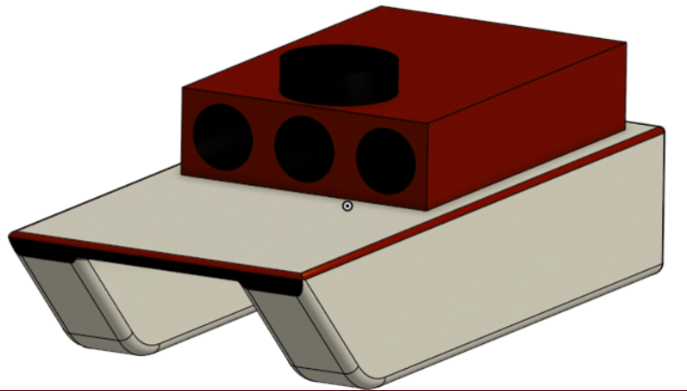

The next concept we came up with is the following:

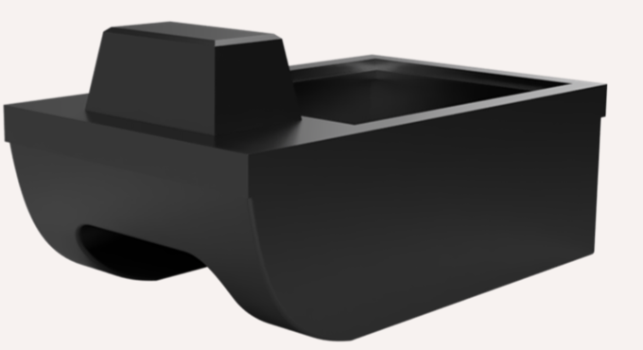

To be able to do a hand layup using fiberglass, we first had to build a mold:

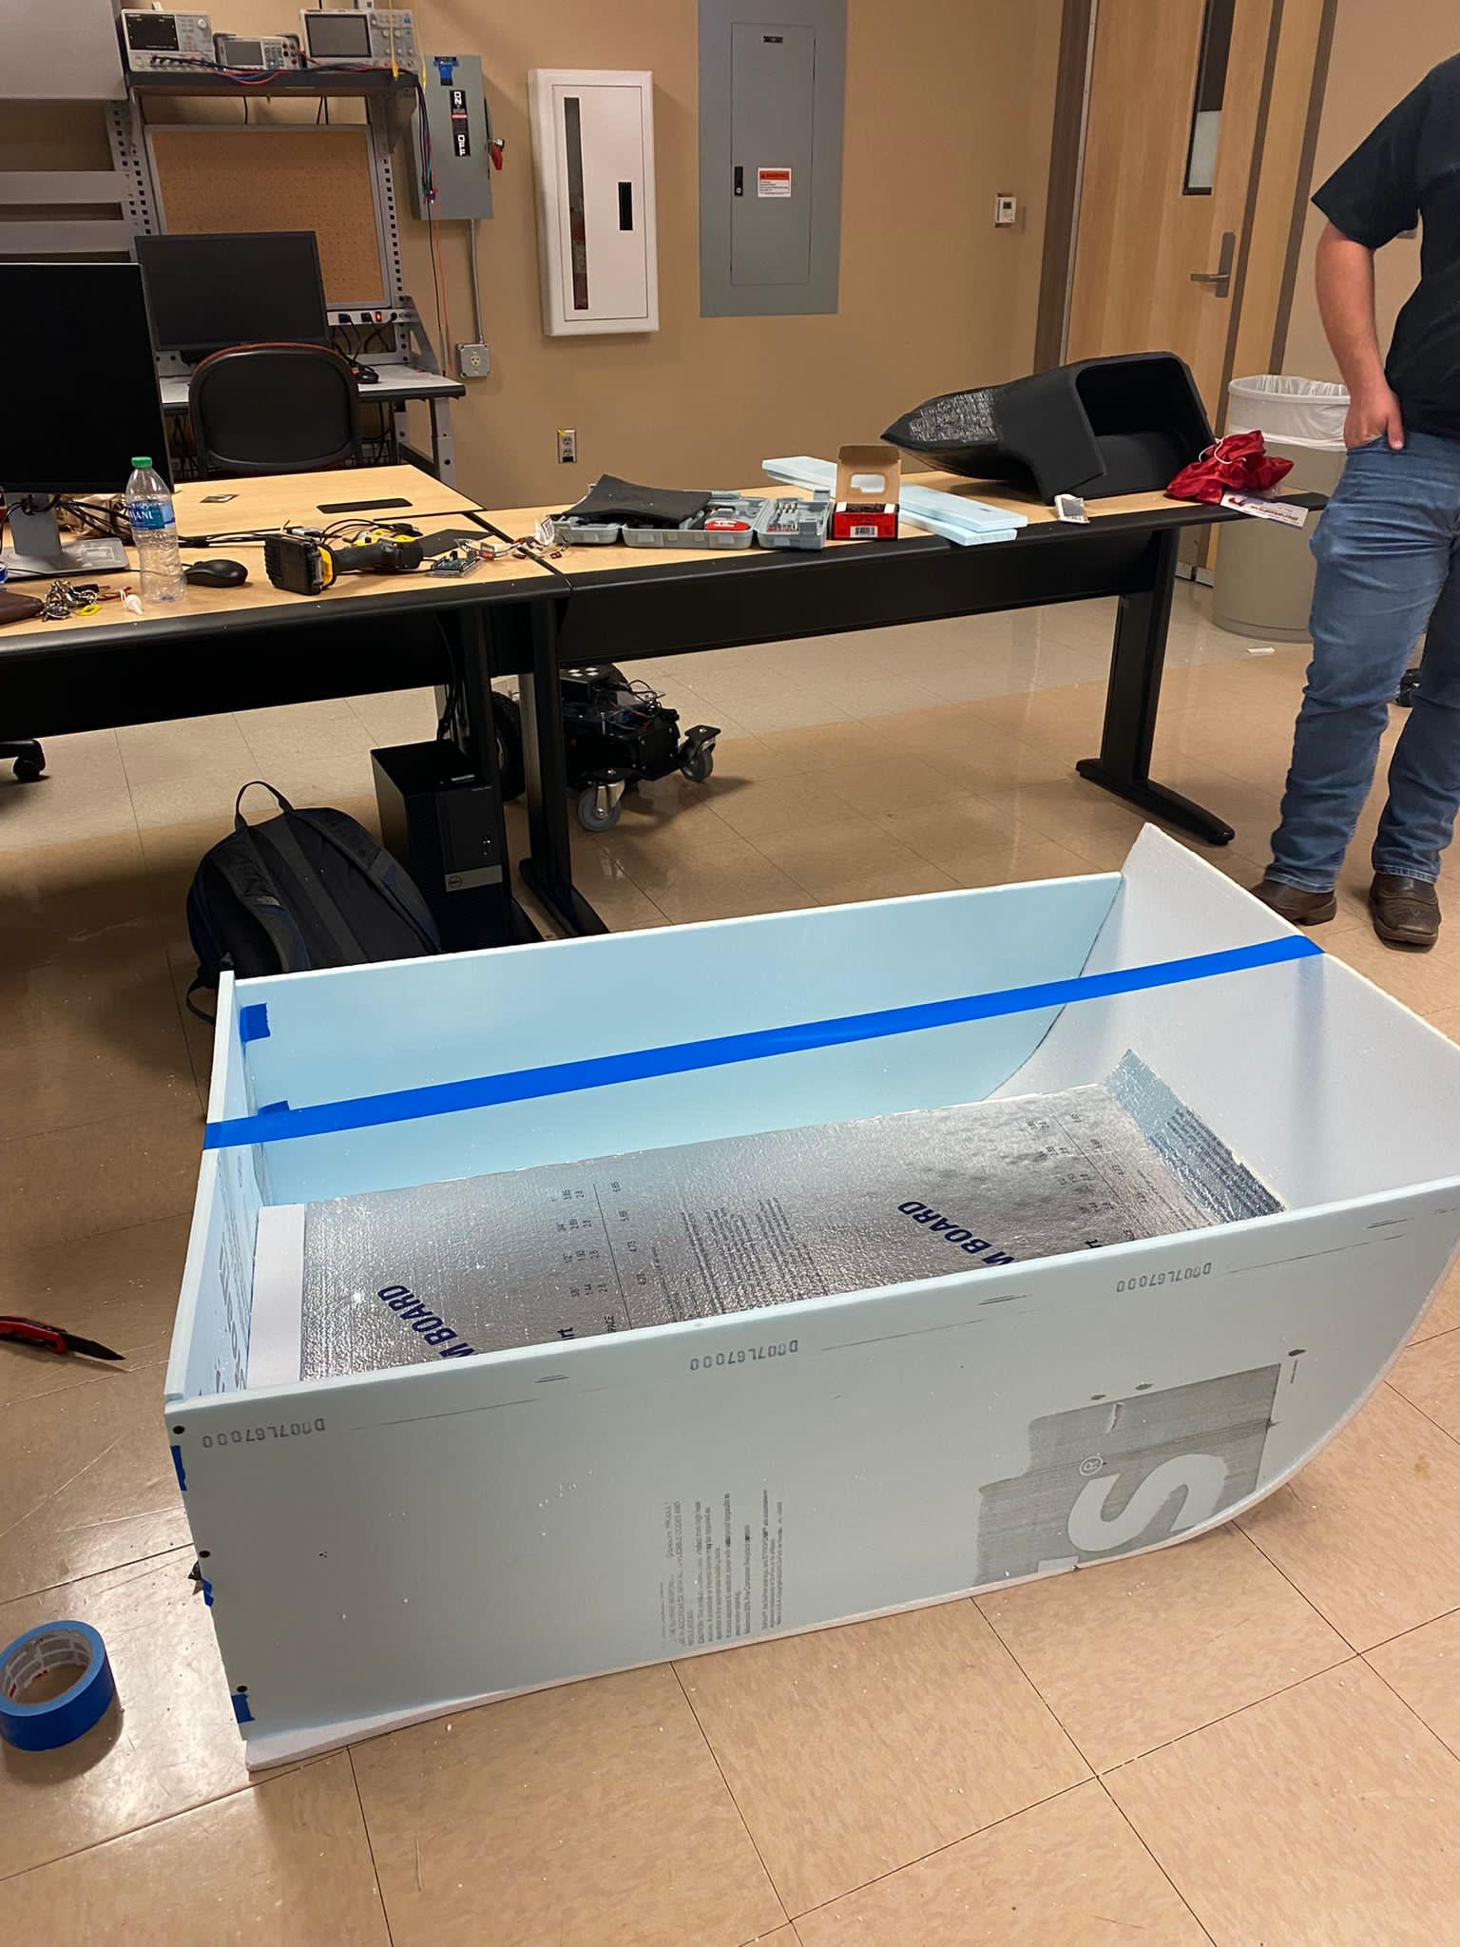

After building the mold, we did a hand layup of the fiberglass. The boat hull was 3 layers and the lid was 6 layers.

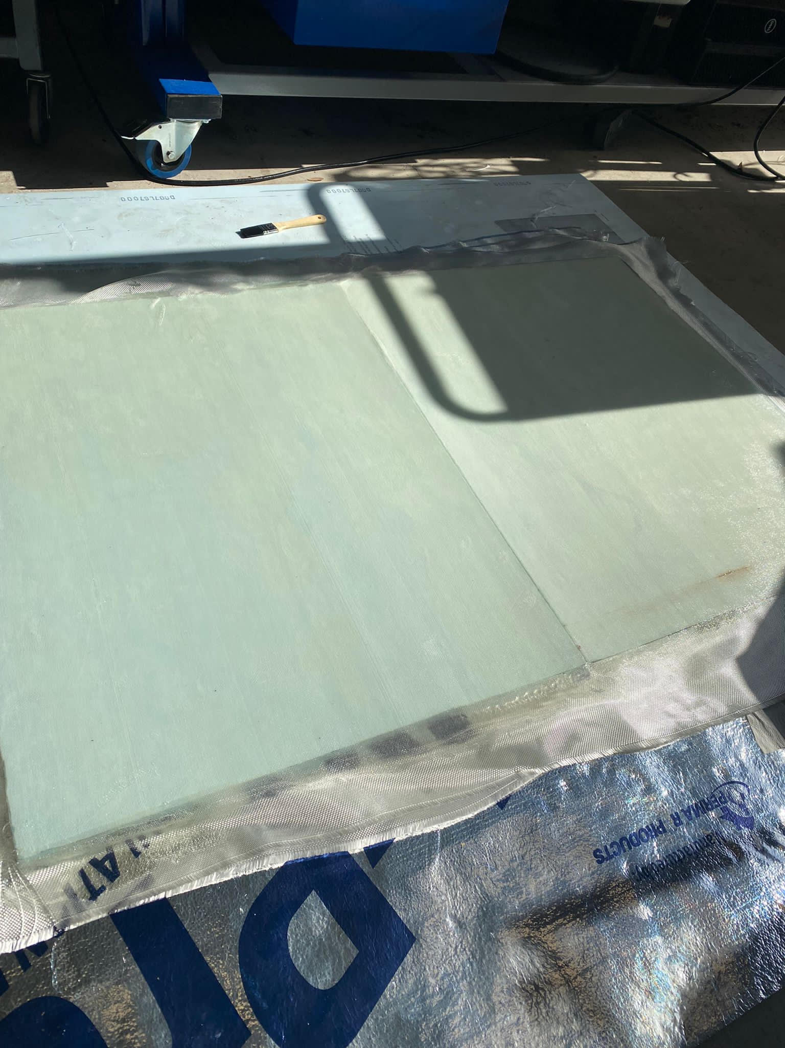

*The lid

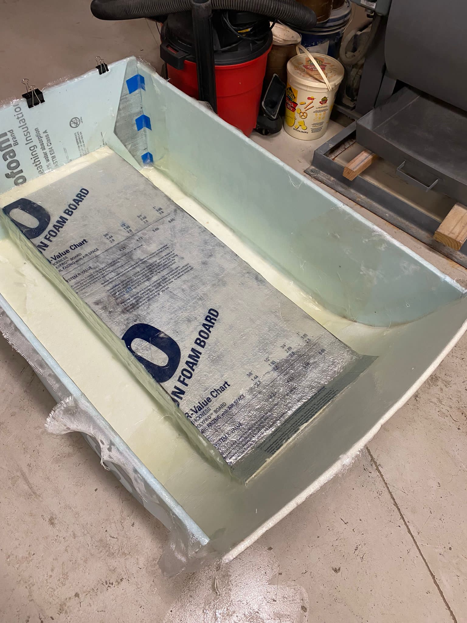

*The hull

Then we removed the mold from the dried fiberglass, checked and repaired any holes found and put it in the water for a leak test. 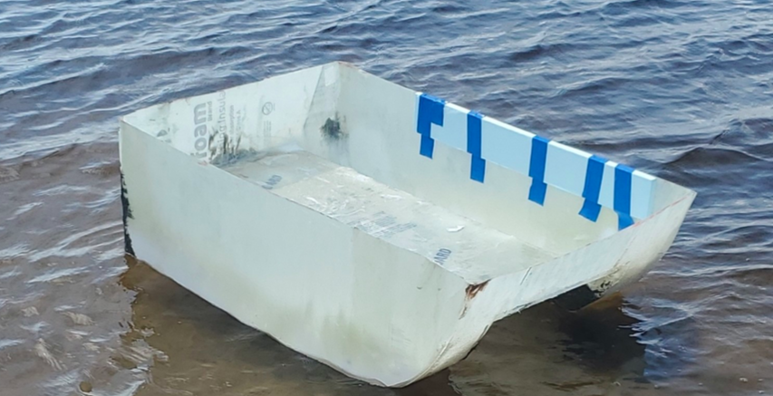

After the boat was repaired and had no leaks, the hull and lid were painted.

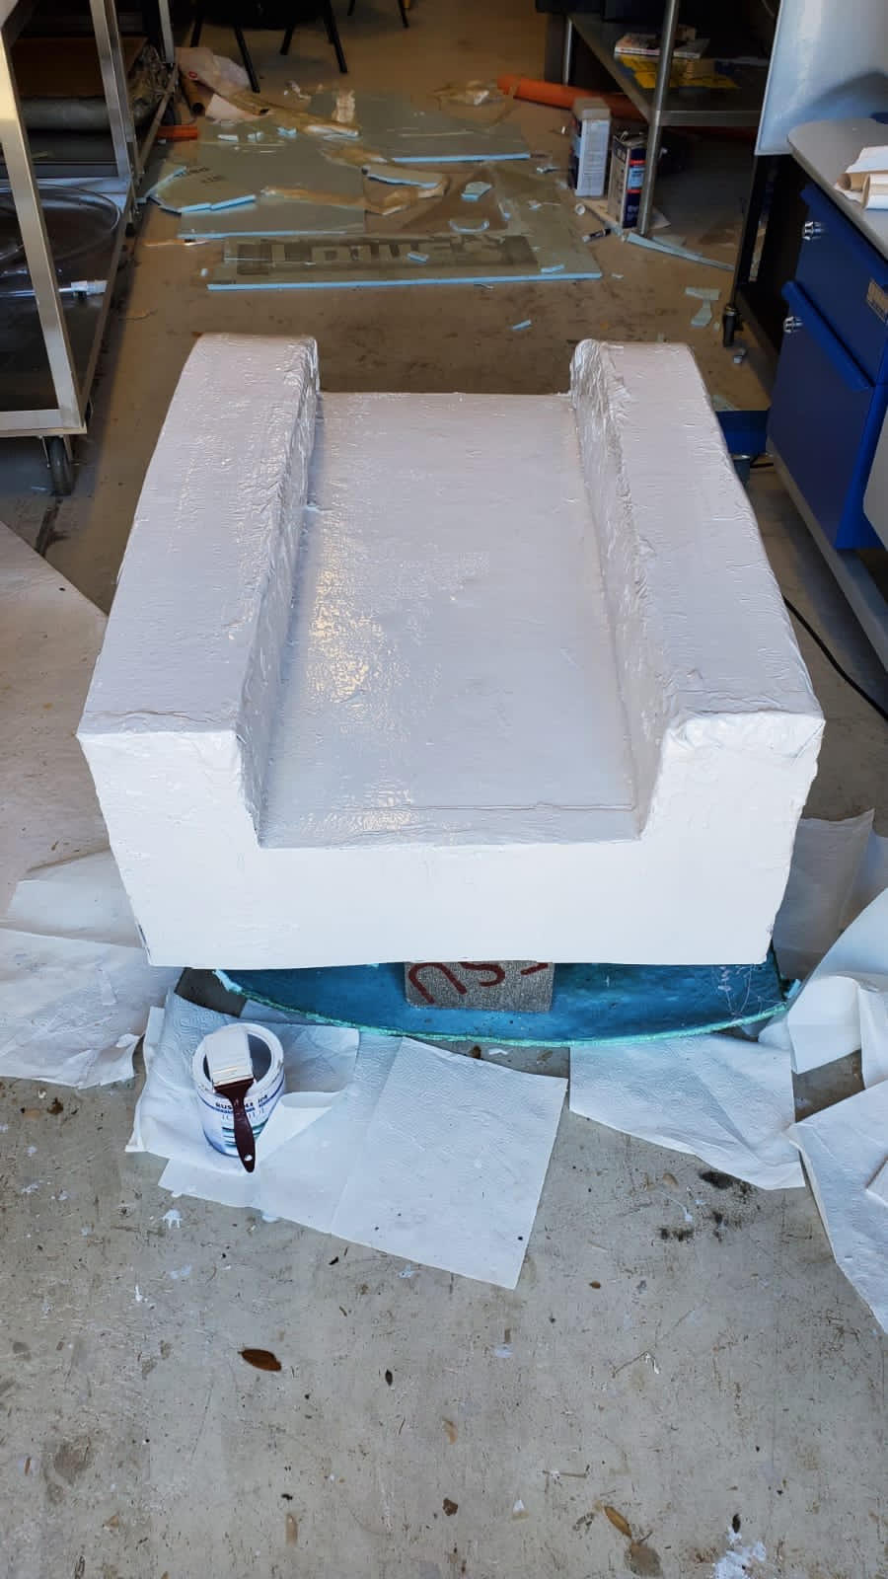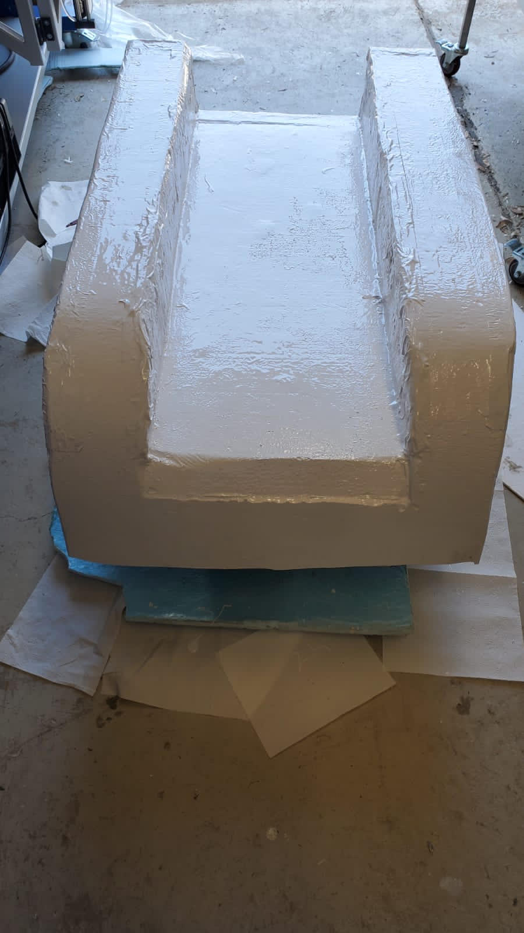

The following is a picture of the lidar tilt mechanism. This is mounted on the front of the lid.

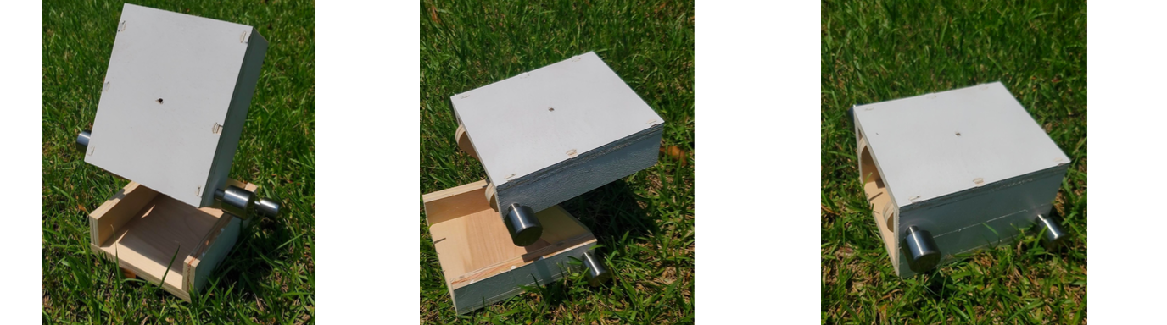

Next is the propulsion hot swap system we implemented on the boat. The bottom part of the fins are glued to the bottom part of the boat. The fins that slide off allow the propellers to be changed with ease.

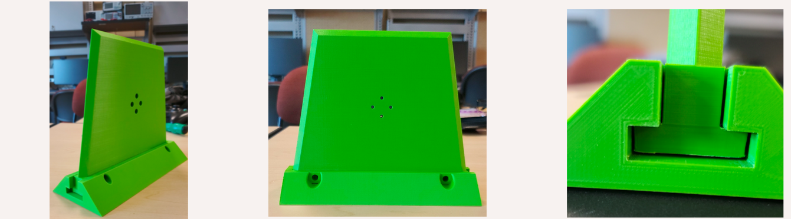

The final product is the following picture:

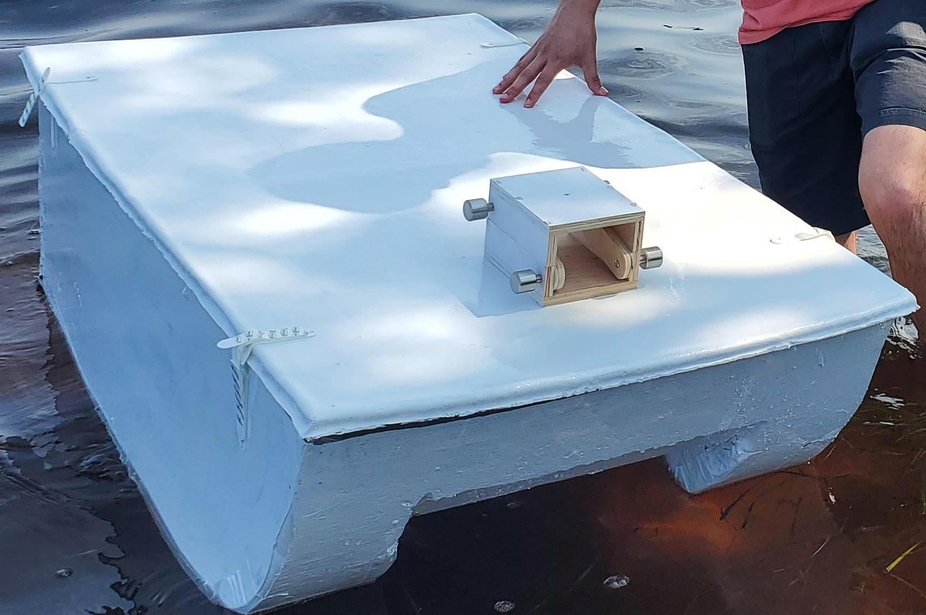

**Integration**

The project was started making a mold out of foam. The mold was then sprayed with pam to help the foam not stick to the fiberglass once it was dry. Once that was made, we did a hand layup out of fiberglass using an epoxy resin for fiberglass. We did 3 layers of fiberglass for the hull and 6 layers on the lid. Also, we left the foam from the mold on the lid to act as extra support. After the fiberglass was dried, we removed the foam from it. Then we checked for and repaired any holes we found after doing multiple float tests. Once the boat was not leaking, we painted it and glued on the propulsion hot swaps and lidar tilt mechanism as our final product. The electrical engineers are going to be working on integrating the hardware and software onto the boat to allow it to be remote controllable.

**Operation**

***Boat Hull***

To operate the boat hull, place the boat into the water with the pontoons going into the water first, be careful not to let water into the hull if operating without the lid. If water is let into the hull, use a towel to dry it.

***Boat Lid***

To operate the lid, place the lid on the boat hull with the tilt mechanism facing the front of the boat. Using the velcro straps, strap the lid to the boat hull to secure the lid onto the hull.

***Tilt Mechanism***

To use the tilt mechanism, loosen the silver knobs to allow for easy manipulation. Tilt the device to the desired height and tighten the bottom knobs (closest to the lid), tilt the device to the desired angle for the LiDAR to sit at and tighten the knobs (furthest from the lid). Use a Phillips head screwdriver if the device is not achieving desired stiffness.

***Propulsor Hot-Swaps***

Align the propulsor mount with the holes of the hot-swap fin, using the correct size screwdriver and screws, attach the propulsor to the hot-swap fin. Align the T joint with the hot-swap rack attached to the underside of the boat, and slide in gently, if there is friction attempt to flip the hot-swap fin around and try again, if friction still occurs lightly grease or sand the T joint on the fin.

**Troubleshooting**

Since our portion of the project focused on the manufacturing and fabrication of the boat hull, the main concern with that is if the boat starts leaking. To be able to fix a leak, use either flex seal or fiberglass hole repair in order to cover the hole completely. Let the remedy dry the appropriate amount of time and then test and make sure no water leaks into the boat. If the LiDAR tilt mechanism or the propulsor hot-swaps were to come off, be sure to apply a strong, waterproof adhesive (gorilla glue, super glue, etc.) and let it sit for an appropriate amount of time prior to putting it in the water. Lastly, if the velcro straps were to come unglued, be sure to apply the appropriate adhesive and let it sit and dry, or a feasible option is to replace the velcro.

# 

# **High Resolution Graphic**

# 

Figure 21: High Resolution Graphic

# **Team Photo**

# 

Figure 22: Team Photo

# **Appendix**



**Figure 1: Functional Decomposition**



**Figure 2: Stability of Boats in regards to Center of Gravity vs Center of Buoyancy**



**Figure 3a. Stable**



**FIgure 3b. Unstable**



**Figure 4. Buoy Set-Up**



**Figure 5. Weight and Thrust measurement Systems**

**Concept 1**



**Figure 6: Concept 1 Perspective View**



**Figure 6: Concept 1 Front View**

**Figure 6: Concept 1 Additional Views**

** **

**Rear View Cross-Section View**

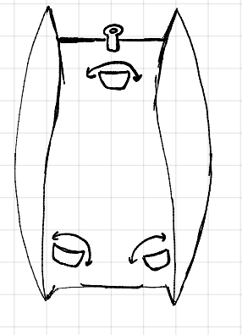

**Bottom View Top View**

**Concept 2**



**Figure 7: Concept 2 Perspective View**

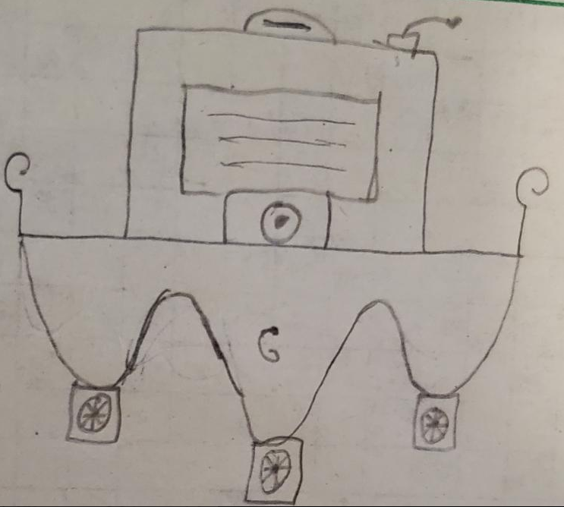

**Figure 7: Concept 2 Front View**

**Figure 7: Concept 2 Additional Views**

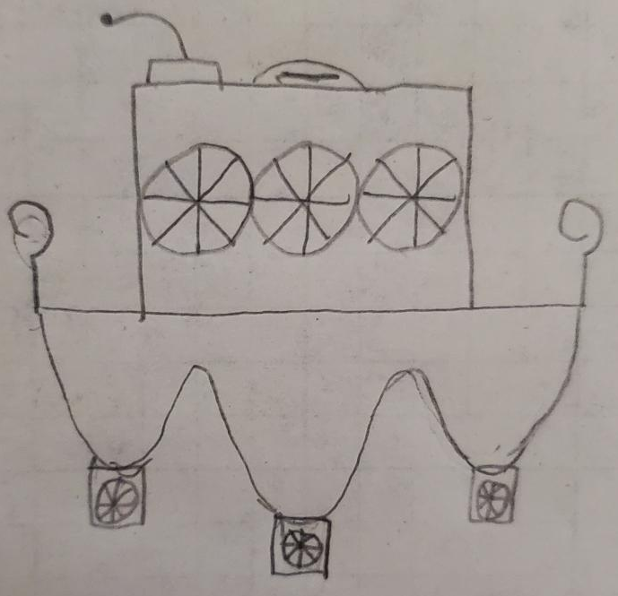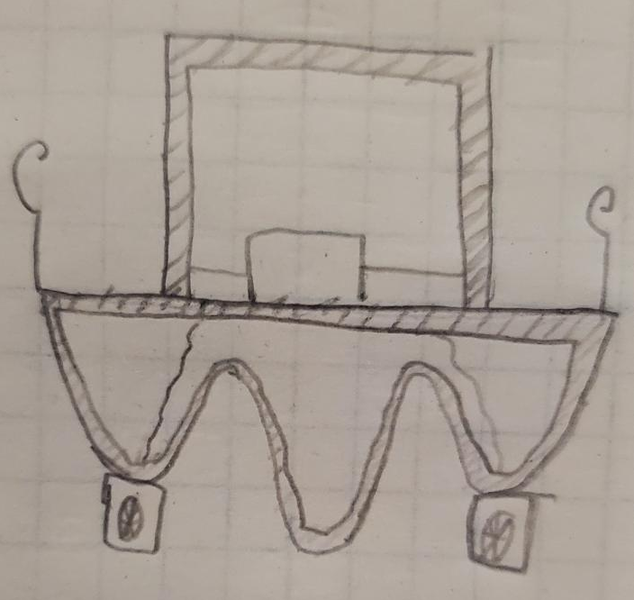

**Rear View Cross-Section View**

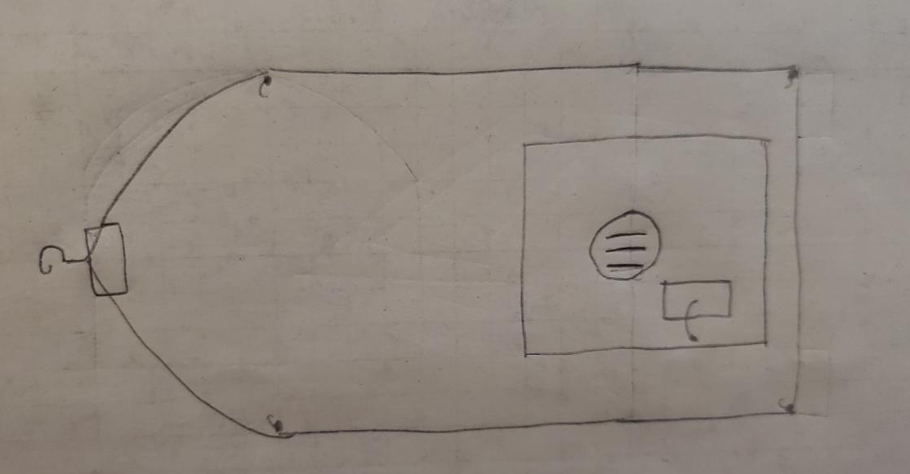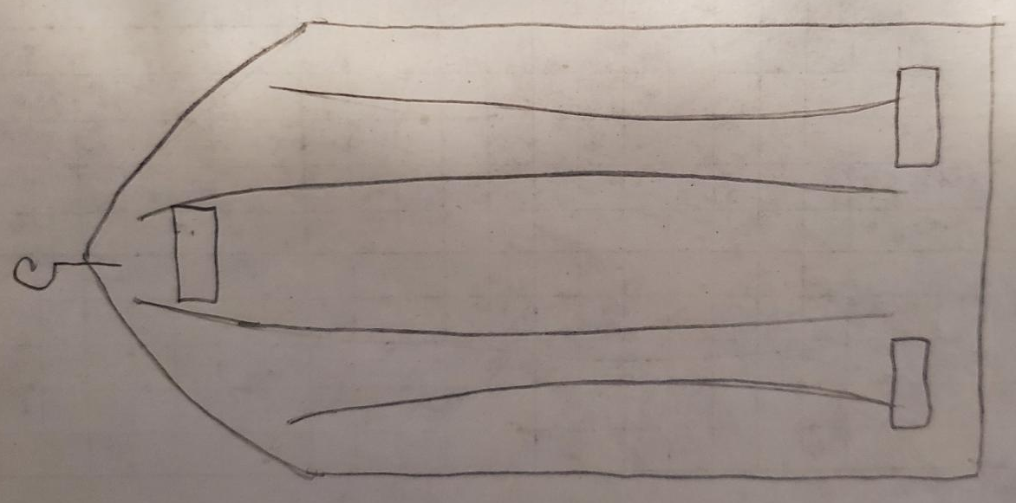

**Top View Bottom View**

**Concept 3**



**Figure 8: Concept 3 Perspective View**

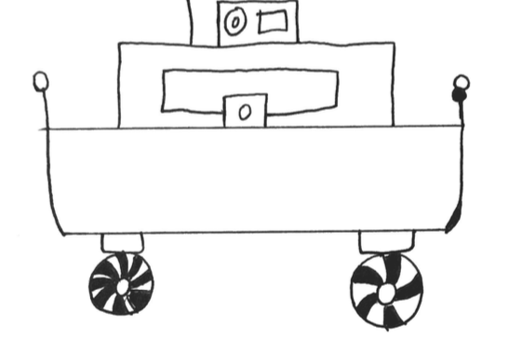

**Figure 8: Concept 3 Front View**

**Figure 8: Concept 3 Additional Views**

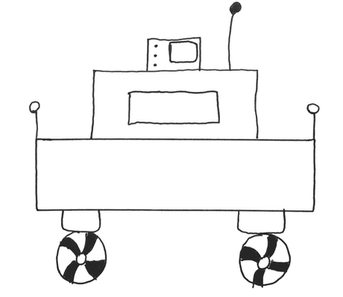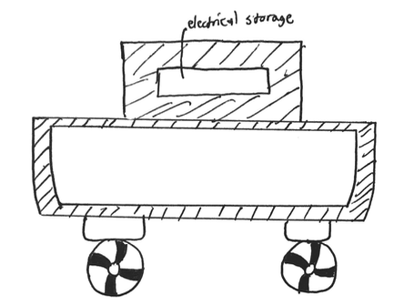

**Rear View Cross-Section View**

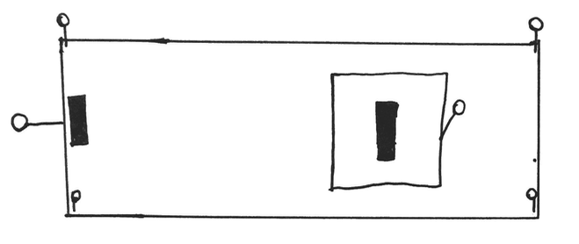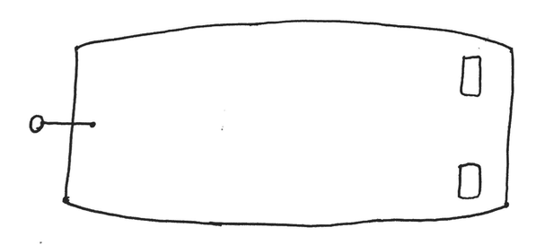

**Top View Bottom View**

**Concept 4**



**Figure 9: Concept 4 Perspective**

**Figure 9: Concept 4 Additional Views**

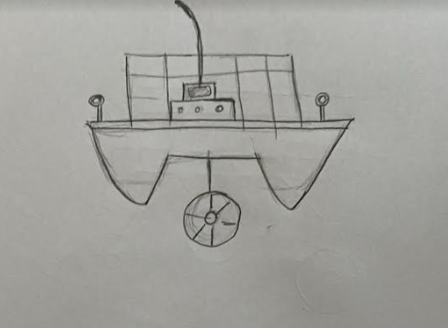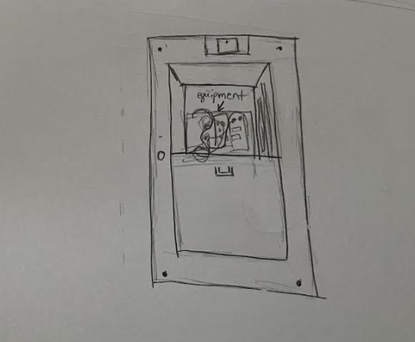

**Front View Top View**

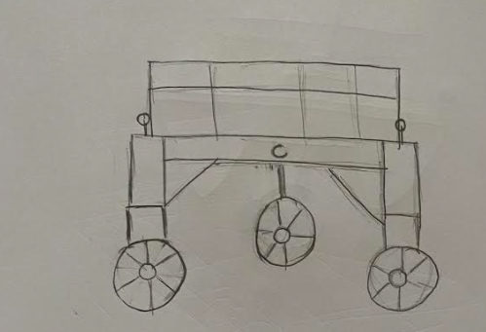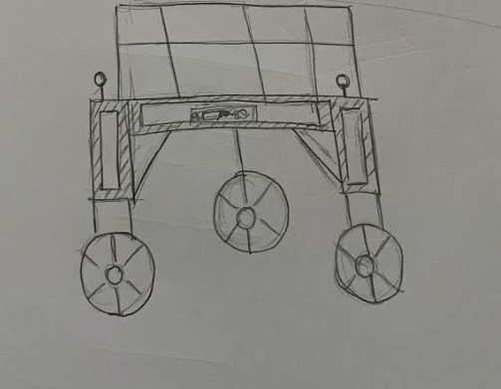

**Rear View Cross-section View**

**Concept 5**



**Figure 10: Concept 5 Perspective VIew**

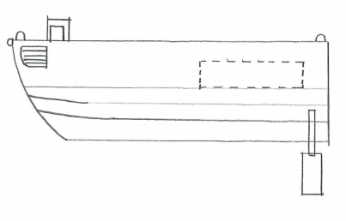

**Figure 10: Concept 5 Side View**

**Figure 10 : Concept 5 Additional VIews**

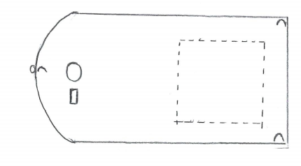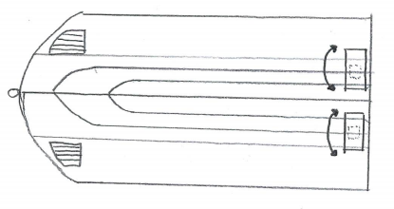

**Top View Bottom View**

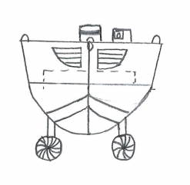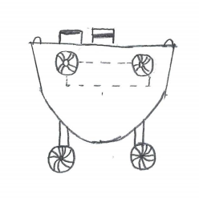

**Front View Back View**



Figure 18: Timeline as of Phase 1



Figure 19: Competition Challenges





Figure 20: Boat Prototype Model

# 

Figure 21: High Resolution Graphic

# 

**Figure 22: Team Photo**

# 

|  |  |  |  |  |  |  |
| --- | --- | --- | --- | --- | --- | --- |
| **SENIOR DESIGN: ROBOBOAT** | | | | | | |
| **LEVEL** | | | **TASK** | **PERCENTAGE** | **STATUS** | **PERSON(S)** |
| **1.0** |  |  | **ROBOBOAT PROJECT** | 100% | Complete | Team |
|  | **1.1** |  | **Milestone 1: WBS** | 100% | Complete | Team |
|  |  | **1.1.1** | *-Break down the project milestones into the work that must be done to complete these items.* | 100% | Complete | Bryson Potts |
|  | **1.2** |  | **Milestone 2: PROJECT CHARTER** | 100% | Complete |  |
|  |  | **1.2.1** | *-Create a Mission Statement* | 100% | Complete | Bryson Potts |
|  |  | **1.2.2** | *-Create a Project Description* | 100% | Complete | Joseph Earnest |
|  |  | **1.2.3** | *-Identify market* | 100% | Complete | Manning Owens |
|  |  | **1.2.4** | *-Identify Stakeholders* | 100% | Complete | Steven Harrington |
|  |  | **1.2.5** | *-Develop Assumptions* | 100% | Complete | Tamara Mccaskill |
|  |  | **1.2.6** | *-Define Key Goals* | 100% | Complete | Bryson Potts |
|  |  | **1.2.7** | *-Assign Team Roles and Responsibilities* | 100% | Complete | Joseph Earnest |
|  |  | **1.2.8** | *-Create a Communication Policy* | 100% | Complete | Manning Owens |
|  |  | **1.2.9** | *-Develop a Dress Code Policy* | 100% | Complete | Steven Harrington |
|  |  | **1.2.10** | *-Develop an Attendance Policy* | 100% | Complete | Tamara Mccaskill |
|  |  | **1.2.11** | *-Create Statement of Understanding* | 100% | Complete | Bryson Potts |
|  |  | **1.2.12** | *-Develop Code of Conduct Policy* | 100% | Complete | Joseph Earnest |
|  |  | **1.2.13** | *-Submit a hard copy on canvas* | 100% | Complete | Manning Owens |
|  | **1.3** |  | **Milestone 3: CUSTOMER NEEDS** | 100% | Complete |  |
|  |  | **1.3.1** | *-Develop a Customer Needs Statement* | 100% | Complete | Steven Harrington |
|  |  | **1.3.2** | *-Create questions to ask customer* | 100% | Complete | Tamara Mccaskill |
|  |  | **1.3.3** | -Create customer responses | 100% | Complete | Bryson Potts |
|  |  | **1.3.4** | *-Describe how customer needs are being turned into a specification* | 100% | Complete | Joseph Earnest |
|  | **1.4** |  | **Milestone 4: FUNCTIONAL DECOMPOSITION** | 100% | Complete |  |
|  |  | **1.4.1** | *-Create a functional decomposition chart for boat (using software)* | 100% | Complete | Manning Owens |
|  |  | **1.4.2** | *-Identify major functions* | 100% | Complete | Steven Harrington |
|  |  | **1.4.3** | *-Identify sub-functions* | 100% | Complete | Tamara Mccaskill |
|  |  | **1.4.4** | *-Explain how sublevels correlate to the high level function of each column* | 100% | Complete | Bryson Potts |
|  |  | **1.4.5** | *-Identify physical action and expected outcome* | 100% | Complete | Joseph Earnest |
|  | **1.5** |  | **Milestone 5: PHASE 1 DESIGN REVIEW** | 100% | Complete |  |
|  |  | **1.5.1** | *- Develop and submit presentation* | 100% | Complete | Manning Owens |
|  |  | **1.5.2** | *- Introduction* | 100% | Complete | Steven Harrington |
|  |  | **1.5.3** | *- Project Brief Summary* | 100% | Complete | Tamara Mccaskill |
|  |  | **1.5.4** | *- Background* | 100% | Complete | Bryson Potts |
|  |  | **1.5.5** | *- Design Status* | 100% | Complete | Joseph Earnest |
|  |  | **1.5.6** | *- Project Plan (schedule and budget)* | 100% | Complete | Manning Owens |
|  |  | **1.5.7** | *- Score team being observed* | 100% | Complete | Steven Harrington |
|  | **1.6** |  | **Milestone 6 : TARGETS** | 100% | Complete |  |
|  |  | **1.6.1** | *- Generate and log the targets* | 100% | Complete | Tamara Mccaskill |
|  |  | **1.6.2** | *- Write summary of the targets* | 100% | Complete | Bryson Potts |
|  |  | **1.6.3** | *- Write summary of how targets were established* | 100% | Complete | Joseph Earnest |
|  |  | **1.6.4** | *- Write about the targets that interest the customer (customer needs)* | 100% | Complete | Manning Owens |
|  | **1.7** |  | **Milestone 7: CONCEPT GENERATION** | 100% | Complete |  |
|  |  | **1.7.1** | *- Generate and submit concepts* | 100% | Complete | Steven Harrington |
|  |  | **1.7.2** | *- 5 Medium Fidelity Concepts* | 100% | Complete | Tamara Mccaskill |
|  |  | **1.7.3** | *- 3 High Fidelity Concepts* | 100% | Complete | Bryson Potts |
|  |  | **1.7.4** | *- 100+ Concepts made* | 100% | Complete | Joseph Earnest |
|  | **1.8** |  | **Milestone 8 : CONCEPT SELECTION** | 100% | Complete |  |
|  |  | **1.8.1** | *- Using an engineering decision making document, designate a winning concept* | 100% | Complete | Manning Owens |
|  |  | **1.8.2** | *- House of Quality* | 100% | Complete | Steven Harrington |
|  |  | **1.8.3** | *- Pugh Charts* | 100% | Complete | Tamara Mccaskill |
|  |  | **1.8.4** | *- AHP* | 100% | Complete | Bryson Potts |
|  |  | **1.8.5** | *- Final Selection* | 100% | Complete | Joseph Earnest |
|  | **1.9** |  | **Milestone 9: PHASE 2 DESIGN REVIEW** | 100% | Complete |  |
|  |  | **1.9.1** | *- Develop and submit presentation* | 100% | Complete | Manning Owens |
|  |  | **1.9.2** | *- Targets* | 100% | Complete | Steven Harrington |
|  |  | **1.9.3** | *- Concept Generation* | 100% | Complete | Tamara Mccaskill |
|  |  | **1.9.4** | *- Concept Selection* | 100% | Complete | Bryson Potts |
|  |  | **1.9.5** | *- Design Status* | 100% | Complete | Joseph Earnest |
|  |  | **1.9.6** | *- Future Plans* | 100% | Complete | Manning Owens |
|  |  | **1.9.7** | *- Score team being observed* | 100% | Complete | Steven Harrington |
|  | **1.10** |  | **Milestone 10: BILL OF MATERIALS** | 100% | Complete |  |
|  |  | **1.10.1** | *- Develop and submit the Bill of Materials* | 100% | Complete | Tamara Mccaskill |
|  |  | **1.10.2** | *- Bill of Materials* | 100% | Complete | Bryson Potts |
|  | **1.11** |  | **Milestone 11: PROTOTYPE PLAN** | 100% | Complete |  |
|  |  | **1.11.1** | **- No current information available** | 100% | Complete | Joseph Earnest |
|  | **1.12** |  | **Milestone 12: RISK ASSESSMENT** | 100% | Complete |  |
|  |  | **1.12.1** | *- Complete and submit the safety forms* | 100% | Complete | Joseph Earnest |
|  |  | **1.12.2** | *- Safety Expectations* | 100% | Complete | Manning Owens |
|  |  | **1.12.3** | *- Worksheet 1 (project hazard assessment)* | 100% | Complete | Steven Harrington |
|  |  | **1.12.4** | *- Worksheet 2 (project control)* | 100% | Complete | Tamara Mccaskill |
|  | **1.13** |  | **Milestone 13: SUMMER PROJECT PLAN (WBS UPDATE)** | 100% | Complete |  |
|  |  | **1.13.1** | *- Develop and submit plan for summer* | 100% | Complete | Bryson Potts |
|  |  | **1.13.2** | *- Document timeline, milestones, and deliverables* | 100% | Complete | Joseph Earnest |
|  | **1.14** |  | **Milestone 14 : PHASE 3 DESIGN REVIEW (POSTER)** | 100% | Complete |  |
|  |  | **1.14.1** | *- PDF of poster (24x36 in) summary of all work to this point and future work* | 100% | Complete | Manning Owens |
|  | **1.15** |  | **Milestone 15 : FINAL REPORT (SPRING)** | 100% | Complete |  |

**Table 1: WBS**

|  |  |  |  |
| --- | --- | --- | --- |
| Question | Answer | Interpreted Need | Explanation of Results |
| Would weight be an issue for this project? | It cannot exceed 140 pounds, and would ideally be less than 70 pounds. | The overall weight of the ASV and UAV will be less than 140 pounds. | The data found in the RoboBoat competition guidelines contains the ideal total weight and maximum total weight for the ASV and UAV. |
| Would size be an issue for this project? | The vehicle cannot exceed six feet, by three feet, by three feet "box". | The boat will be smaller than the size constraint given | The data found in the RoboBoat competition guidelines contains the UAV size constraint. |
| What type of water will the boat be operating in? | The competition takes place at a freshwater pond, but you will most likely be testing in saltwater conditions. | The boat will be smaller than the size constraint given. | The buoyancy of the boat may be different in freshwater vs saltwater. |
| Do the electrical components of the boat have to be enclosed? | It is recommended the electrical components are covered. | Electrical components will be covered in case of inopportune weather conditions. | While it is not required that the electrical components be covered, it is highly recommended so that electrical components will not have water damage from rain. |
| When should the final product be completed? | Final demos are within the last two weeks of the summer semester, or if going to a competition plan to finish ideally a week before the competition. | The team needs to decide whether the boat is planned to go to the competition. | If the team competes, then the project has to be completed significantly sooner. |
| What will be the planned transportation for the boat to the competition? | It will be transported in a pickup truck with a covered cab. | The boat needs to be able to fit and be secured in the bed of the truck. | The boat can be damaged if it somehow fell out of the truck while driving down the highway. |
| What aspect of the competition should we prioritize? | Focus on the areas of the competition that will net the most points with the least amount of complexity | Try not to perfect one specific characteristic of the project. | Directing all focus to one aspect of the project can cause problems in other areas and ultimately compromise the design. |
| Can the boat utilize any type of energy source? | The vehicle needs to be battery powered. | The watercraft will have power supplied by a cordless energy source. | The best solution for a cordless energy source is a battery. |
| How much autonomy should our boat have? | The vehicle must be fully autonomous, and all decisions can be made onboard the ASV. | The boat will be capable of making decisions and functioning independently. | The boat will be controlled by a wireless controller. |
| What propulsion systems are available for use? | Any propulsion system is fine (thruster, paddle, etc.), but moving parts must have a shroud. | The propulsion system will be determined by team preference, with a covering in case of moving parts. | The propulsion system that will be used needs to contain some drag to allow the boat to stop quicker. |
| What safety precautions should be taken? | All sharp, pointy, moving, or sensitive parts must be covered and marked. | The boat will have appropriate safety measures befitting of the RoboBoat standards. | All necessary precautions will be taken to assure that no problems will arise during the competition/showcase. |

**Table 2: Customer Needs**

|  |  |  |
| --- | --- | --- |
| Function | Metric | Target |
| Maintain Stability | Buoyancy | Positive buoyancy for >= 30 minutes |
| Weight Distribution | Center of Gravity below Center of Buoyancy |
| Detect Surroundings | Sensor Range | 6 meters |
| Sensing Speed | Value from spec sheet |
| Process | Object Detection | Same as Sensing Speed |
| Move Boat | Thrust | 13-18 lbs |

**Table 3. Critical Targets and Metrics**

|  |  |  |  |  |  |  |  |  |
| --- | --- | --- | --- | --- | --- | --- | --- | --- |
| **Navigation** | **Propulsion** | **Boat Material** | **Control Panel Location** | **Hull** | **Battery Location** | **Vision System** | **Hardware** | **Receiver Location** |
| ROS | Jet Turbine | Carbon Fiber | Inside | Cathedral | Inside | Go-Pro | Arduino | Top |
| Lidar | Propellor | PVC | Front | Catamaran | Top | Sony RX0 II |  | Front |
| Sonar | Fan | Wood | Back | Trimaran | Back | SeaLife DC 2000 |  |  |
|  | Thruster | Fiberglass |  | Pontoon |  | DJI Osmo Action |  |  |
|  |  | Alumunium |  | V-bottom |  |  |  |  |
|  |  |  |  | Flat- Bottom |  |  |  |  |
|  |  |  |  |  |  |  |  |  |

**Table 4: Morphological Chart**



**Table 5: Binary Comparison Chart**



**Table 6: House of Quality**



**Table 7: AHP**



**Table 8: Normalized AHP**



**Table 9: Pugh Chart**



**Table 10: Material Characteristic Comparison**



**Table 11: Decision Matrix**

# **Appendix B - Concept Combinations**

## Concept 1

**Hull Shape** - Catamaran

**Hull Material** - Carbon-Fiber

**Hull Coating** - Flex-Seal

**Propulsion** - Out-Board Propellor

**Propulsion Amount** - 3 Differential Propulsors

**Object Detection Sensor** - LiDAR

**Object Detection Sensor Position** - Top

**Localization** - GPS

**Remote Control Signal** - Radio

**Receiver Location** - Rear

**Power Source** - Battery

**Power Source Location** - Interior Hull

**Visual Feedback Camera Location** - Front

**Electronics Enclosure** - Acrylic

**Cooling System** - Fan (Active Intake) + Fan (Active Outtake)

**Tow Harness Location** - Front

**Deployment Harness Location** - 4 points (1 in each corner)

**Concept 2**

**Hull Shape** - Tri-Hull (Tunnel Hull)

**Hull Material** - Fiber-Glass

**Hull Coating** - Paint

**Propulsion** - Outboard Propeller

**Propulsion Amount** - 2 Differential Propulsors + 1 Propulsor

**Object Detection Sensor** - Ultrasonic

**Object Detection Sensor Position** - Top

**Localization** - GPS

**Remote Control Signal** - BlueTooth

**Receiver Location** - Top

**Power Source** - Battery Powered

**Power Source Location** - Rear

**Visual Feedback Camera Location** - Front

**Electronics Enclosure** - Plastic Box (PLA)

**Cooling System** - Vents (passive intake) + Fan (active outtake)

**Tow Harness Location** - Front

**Deployment Harness Location** - 4 Point Harness (1 in each corner)

**Concept 3**

**Hull Shape** - Flat Bottom

**Hull Material** - Aluminum

**Hull Coating** - Flex-Seal

**Propulsion** - Inboard Propellor

**Propulsion Amount** - 2 Differential Propulsors

**Object Detection Sensor** - LiDAR

**Object Detection Sensor Position** - Front

**Localization** - GPS

**Remote Control Signal** - Radio

**Receiver Location** - Rear

**Power Source** - Battery

**Power Source Location** - Interior Hull

**Visual Feedback Camera Location** - Top

**Electronics Enclosure** - Wooden

**Cooling System** - Vent (passive intake) + Vent (passive intake)

**Tow Harness Location** - Belly of Boat

**Deployment Harness Location** - 4 points (1 in each corner)

**Concept 4**

**Hull Shape** - Pontoon

**Hull Material** - Wood

**Hull Coating** - Epoxy Resin

**Propulsion** - Onboard Propellor

**Propulsion Amount** - 3 Propulsors

**Object Detection Sensor** - LiDAR

**Object Detection Sensor Position** - Front

**Localization** - GPS

**Remote Control Signal** - Bluetooth

**Receiver Location** - front

**Power Source** - Battery

**Power Source Location** - Interior Hull

**Visual Feedback Camera Location** - Top

**Electronics Enclosure** - Plastic

**Cooling System** - Vent (passive intake) + Vent (passive intake)

**Tow Harness Location** - Rear

**Deployment Harness Location** - 4 points (1 in each corner)

**Concept 5**

**Hull Shape:** V-Bottom

**Hull Material:** Fiberglass

**Hull Coating:** Hydrophobic Spray

**Propulsion:** Out-Board Propeller

**Propulsion Amount:** 2 differential propulsors

**Object Detection Sensor:** LiDAR

**Object Detector Location:** Front

**Localization:** GPS

**Remote Control Signal:** BlueTooth

**Receiver Location:** Rear

**Power Source:** Battery Power Source

**Power Source Location:** Interior Hull

**Visual Feedback Camera Location:** Front

**Electronics Enclosure:** Plastic Box (PLA)

**Cooling System:** Vents (passive intake) + Fan (active outtake)

**Tow Harness Location:** Front

**Deployment Harness Locations:** 3-point harness: 2 hooks in the rear, 1 in the front

# **Appendix C - 100 Possible Concepts**

**Hull Shape**

1. Displacement Hulls
2. Cathedral
3. Planing Hulls
4. Flat Bottom
5. V-Bottom
6. Tri-Hull (Tunnel Hull)
7. Pontoon
8. Semi-Displacement Hulls
9. Multi-Hulls
10. Catamarans
11. Trimarans

**Hull Material**

1. Carbon-Fiber
2. Fiber-Glass
3. Aluminum
4. Stainless Steel
5. Rubber
6. Plastic (PLA)
7. Plastic (ABS)
8. Wood
9. Titanium
10. PVC (Polyvinyl chloride) Pipe
11. Ferro-Cement
12. Polyethylene foam
13. Flex-tape
14. Flex-Seal
15. Aero-Gel

**Hull Coating**

1. Gel
2. Hydrophobic Spray
3. Seamless Polyurea
4. Ceramic Coating
5. Paint
6. Epoxy resin
7. Flex-Seal
8. Flex-Tape
9. Polyurethane
10. Varnish
11. Lacquer
12. Galvanize
13. Powder Coating
14. Penetrol

**Propulsion**

1. Inboard Propeller
2. Outboard Propellor
3. Fan
4. Sailboat
5. Rowing

**Propulsion Amount**

1. 1 propulsor
2. 2 propulsor
3. 3 propulsors
4. 4 propulsors
5. Differential propulsor
6. 2 Differential propulsors
7. 3 Differential propulsors
8. 2 Differential propulsors + 1 propulsors
9. 2 Differential propulsors + 2 propulsors
10. 4 Differential propulsors

**Object Detection Sensor**

1. Ultrasonic
2. InfraRed
3. LiDAR
4. Time of Flight
5. Camera/Image processing

**Object Detection Sensor Position**

1. Front
2. Top
3. Rear

**Localization**

1. GPS
2. Odometer & Gyroscope
3. Triangulation

**Remote Control Signal**

1. BlueTooth
2. Radio
3. Ethernet cable
4. IR signal

**Receiver Location**

1. Front
2. Top
3. Rear

**Power Source**

1. Steam Power
2. Gas Power
3. Solar Power
4. Wind Power
5. Battery Power source

**Power Source Location**

1. Front
2. Top
3. Rear
4. Interior Hull

**Visual Feedback Camera Location**

1. Front
2. Top
3. Rear

**Electronics Enclosure**

1. Yeti enclosure
2. Wooden
3. Acrylic
4. Cardboard Box
5. Carbon-Fiber Box
6. Plastic Box (PLA)
7. Plastic Box (ABS)

**Cooling System**

1. Fans (active intake) + Fan (active outtake)
2. Vents (passive intake) + Fan (active outtake)
3. Fans (active intake) + vent (passive outtake)
4. Vents (passive intake) + vents (passive outtake)
5. Liquid cooling
6. Mineral Water

**Tow Harness Locations**

1. Front
2. Rear
3. Side
4. Corner
5. Belly of the boat

**Deployment Harness Locations**

1. 3 point harness: 2 hooks in the front, 1 in the rear
2. 3 point harness: 2 hooks in the rear, 1 in the front
3. 4 point harness: 1 hook in each corner

# **Appendix D - Bill of Materials**



**Figure 11: Bill of Materials**

# **Appendix E - Risk Management**



**Figure 12**



**Figure 13**



**Figure 14**



**Figure 15**



**Figure 16**



**Figure 17**